BRITISH ANTARCTIC TERRITORY
THIS LICENCE is granted by the Commissioner pursuant to section 2(1)(b) of the Currency Ordinance 1990.
1. Pobjoy Mint Limited of Millennia House, Kingswood Park, Bonsor Drive, Kingswood, Surrey is hereby authorised by this licence to-
a. make during a period of eighteen months from the date of the grant of this licence and
b. issue during a period of two years from the date of the release agreed to between the Government and Mint
coins in the quantities and of the design and specification set out in the
schedule. .
2. It is a condition of this licence that every such coin issued must fully comply with the design and specification set out in the schedule.
3. Each such coin made in accordance with the conditions of this licence shall be legal tender in the Territory for its face value from the first date on which that coin was minted.

THE SCHEDULE
(Design, specification, authorised quantity and authorised mint of coins)
Design:
The obverse of every coin shall consist of the uncouped portrait of Her Majesty Queen Elizabeth II by Ian Rank-Broadley surrounded by the inscription "BRITISH ANTARCTIC TERRITORY" and the year of the minting of the coin.
The reverse design of every coin features an adult female Orca and her calf swimming in the Antarctic waters with an iceberg in the background and the £2, £4 and £20 denomination of the coin respectively at the top as shown in the annex to this Schedule:
Specification, authorised quantity and authorised mint of coins:
Type Silver proof Cupro Nickel Gold proof Gold proof Gold proof

Denomination | £2 | £2 | £2 | £4 | £20
Weight | 28.28 | 28.28 | 0.05 | 1.24 | 6.22
(grams)
Diameter | 38.60 | 38.60 | 11.00 | 13.92 | 22.00
(millimeters)
Fineness | 925 | 75%Cu | 0.999 | 0.999 | 0.999
 |  | 25% Ni
Quality | Proof | Uncirculated | Proof | Proof | Proof
Shape | Round | Round | Round | Round | Round
Edge | Milled | Milled | Milled | Milled | Milled
Quantity | 10,000 | 50,000 | 10,000 | 10,000 | 2,500

ANNEX TO THE SCHEDULE

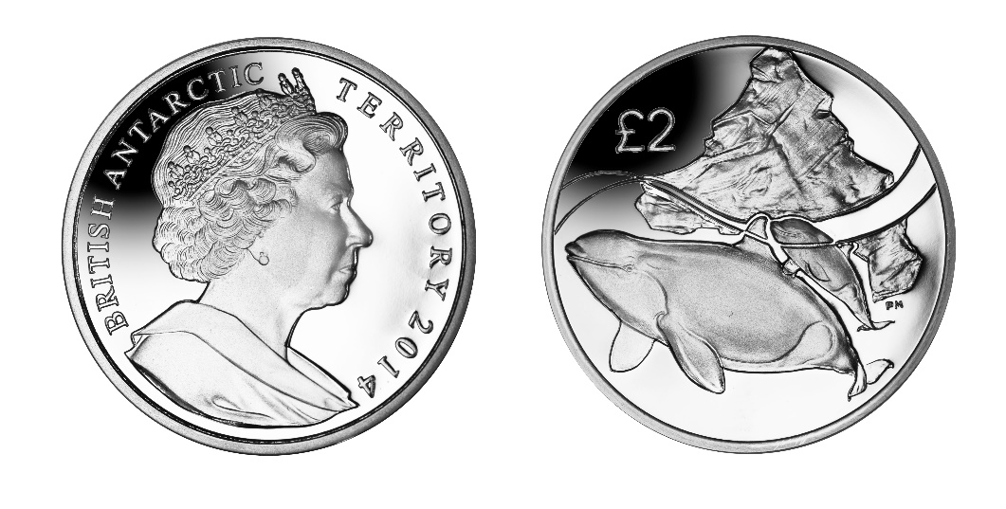

IN WITNESS whereof the Commissioner has hereto set his hand and the Seal of the Territory this 9th day of April 2014.

............................................
Peter Hayes
Commissioner

