BRITISH ANTARCTIC TERRITORY
THIS LICENCE is granted by the Commissioner pursuant to section 2(1)(b) of the Currency Ordinance 1990.
1. Pobjoy Mint Limited of Millennia House, Kingswood Park, Bonsor Drive, Kingswood, Surrey is hereby authorised by this licence to-
a. make during a period of eighteen months from the date of the grant of this licence and
b. issue during a period of two years from the date of the release agreed to between the Government and Mint
coins in the quantities and of the design and specification set out in the
schedule. .
2. It is a condition of this licence that every such coin issued must fully comply with the design and specification set out in the schedule.
3. Each such coin made in accordance with the conditions of this licence shall be legal tender in the Territory for its face value from the first date on which that coin was minted.

THE SCHEDULE
(Design, specification, authorised quantity and authorised mint of coins)
Design:
The obverse of every coin shall consist of the uncouped portrait of Her Majesty Queen Elizabeth II by Pobjoy Mint Ltd surrounded by the inscription "BRITISH ANTARCTIC TERRITORY" and the year of the minting of the coin.
The reverse design of every coin features a family of Crabeater Seals with an adult and cub lying on the Antarctic ice with a further adult seal swimming in the Antarctic waters below and the £2, £4 and £20 denomination of the coin respectively at the base as shown in the annex to this schedule:
Specification, authorised quantity and authorised mint of coins:

Type Silver Proof Cupro Nickel Titanium Gold Proof Gold Proof Gold Proof

Denomination £2 £2 £2 £2 £4 £20

Weight 28.28 28.28 10.00 0.50 1.24 6.22
(grams)

Diameter 38.60 38.60 36.10 11.00 13.92 22.00
(millimeters)

Fineness 925 75% Cu 990 0.999 0.999 0.999
25% Ni

Quality Proof Uncirculated Proof Proof Proof Proof

Shape Round Round Round Round Round Round

Edged Milled Milled Milled Milled Milled Milled

Quantity 2,000 10,000 7,500 10,000 10,000 2,500

ANNEX TO THE SCHEDULE

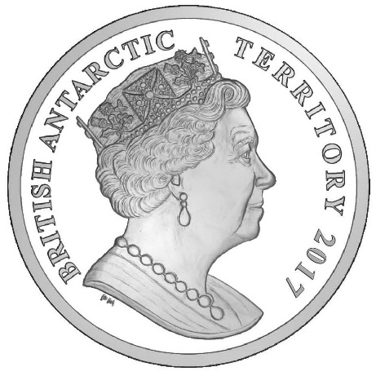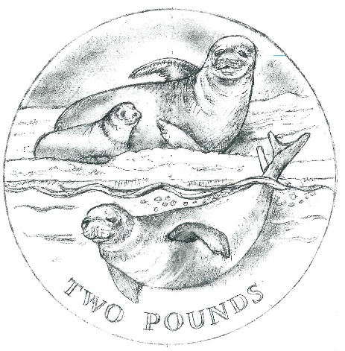

IN WITNESS whereof the Commissioner has hereto set his hand and the Seal of the Territory this 24th day of March 2017.

[SEALED]
[Signed by John Kittmer]
Commissioner

