BRITISH ANTARCTIC TERRITORY

THIS LICENCE is granted by the Commissioner pursuant to section 2(1)(b) of the Currency Ordinance 1990.

1. Pobjoy Mint Limited of Millennia House, Kingswood Park, Bonsor Drive, Kingswood, Surrey is hereby authorised by this licence to-

- make during a period of eighteen months from the date of the grant
of this licence and

- issue during a period of two years from the date of the release agreed
to between the Government and Mint

coins in the quantities and of the designs and specifications set out in the schedule.

2. It is a condition of this licence that every such coin issued must fully comply with a design and specification set out in the Schedule.

3. Each such coin made in accordance with the conditions of this licence shall be legal tender in the Territory for its face value from the first date on which that coin was minted.

THE SCHEDULE
(Design, specification, authorised quantity and authorised mint of coins)

Design:

As shown in the Annex to this Schedule:

The obverse of every coin shall consist of the couped portrait of Her Majesty Queen Elizabeth II by Pobjoy Mint Ltd surrounded by the inscription "BRITISH ANTARCTIC TERRITORY" and the year of the minting of the coin.

The reverse designs are as follows:

- Adélie Penguin – design features a male and female Adélie penguin.
- Chinstrap Penguin – design features a male and female Chinstrap penguin.
- Emperor Penguin – the design features a male and female Emperor penguin.
- Gentoo Penguin – the design features a male and female Gentoo penguin.
- Macaroni Penguin – the design features a male and female Macaroni penguin.

The 50p denomination of the coin appears at the base.
Specification, authorised quantity and authorised mint of coins:

Type Cupro Nickel Cupro Nickel
Uncirculated Diamond Finish
Denomination 50p 50p

Weight (gms) 8.00gms 8.00gms

Diameter (mm) 27.30mm 27.30mm

Fineness 75%Cu/25%Ni 75%Cu/25%Ni
Quality Uncirculated Diamond Finish

Shape Heptagonal Heptagonal

Edge Plain Plain

Quantity Unlimited 4,000

ANNEX TO THE SCHEDULE
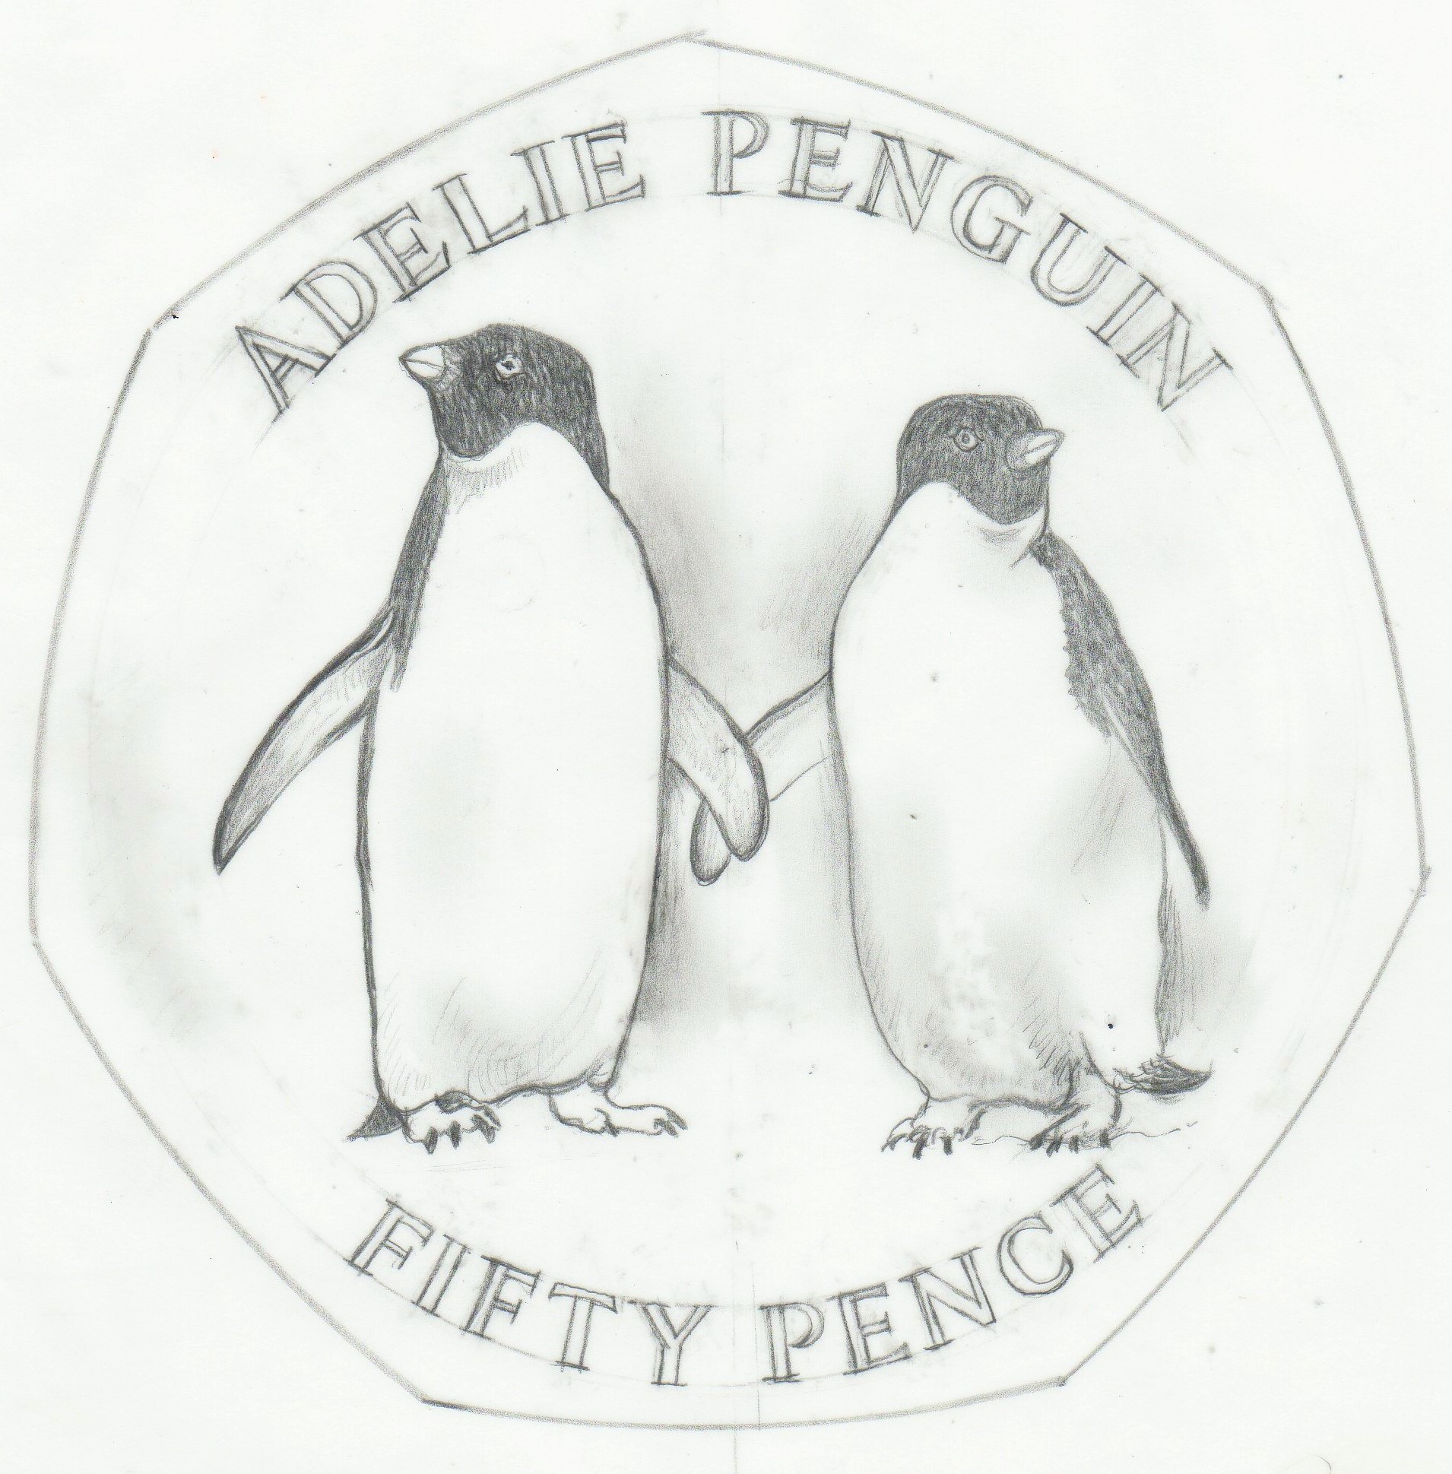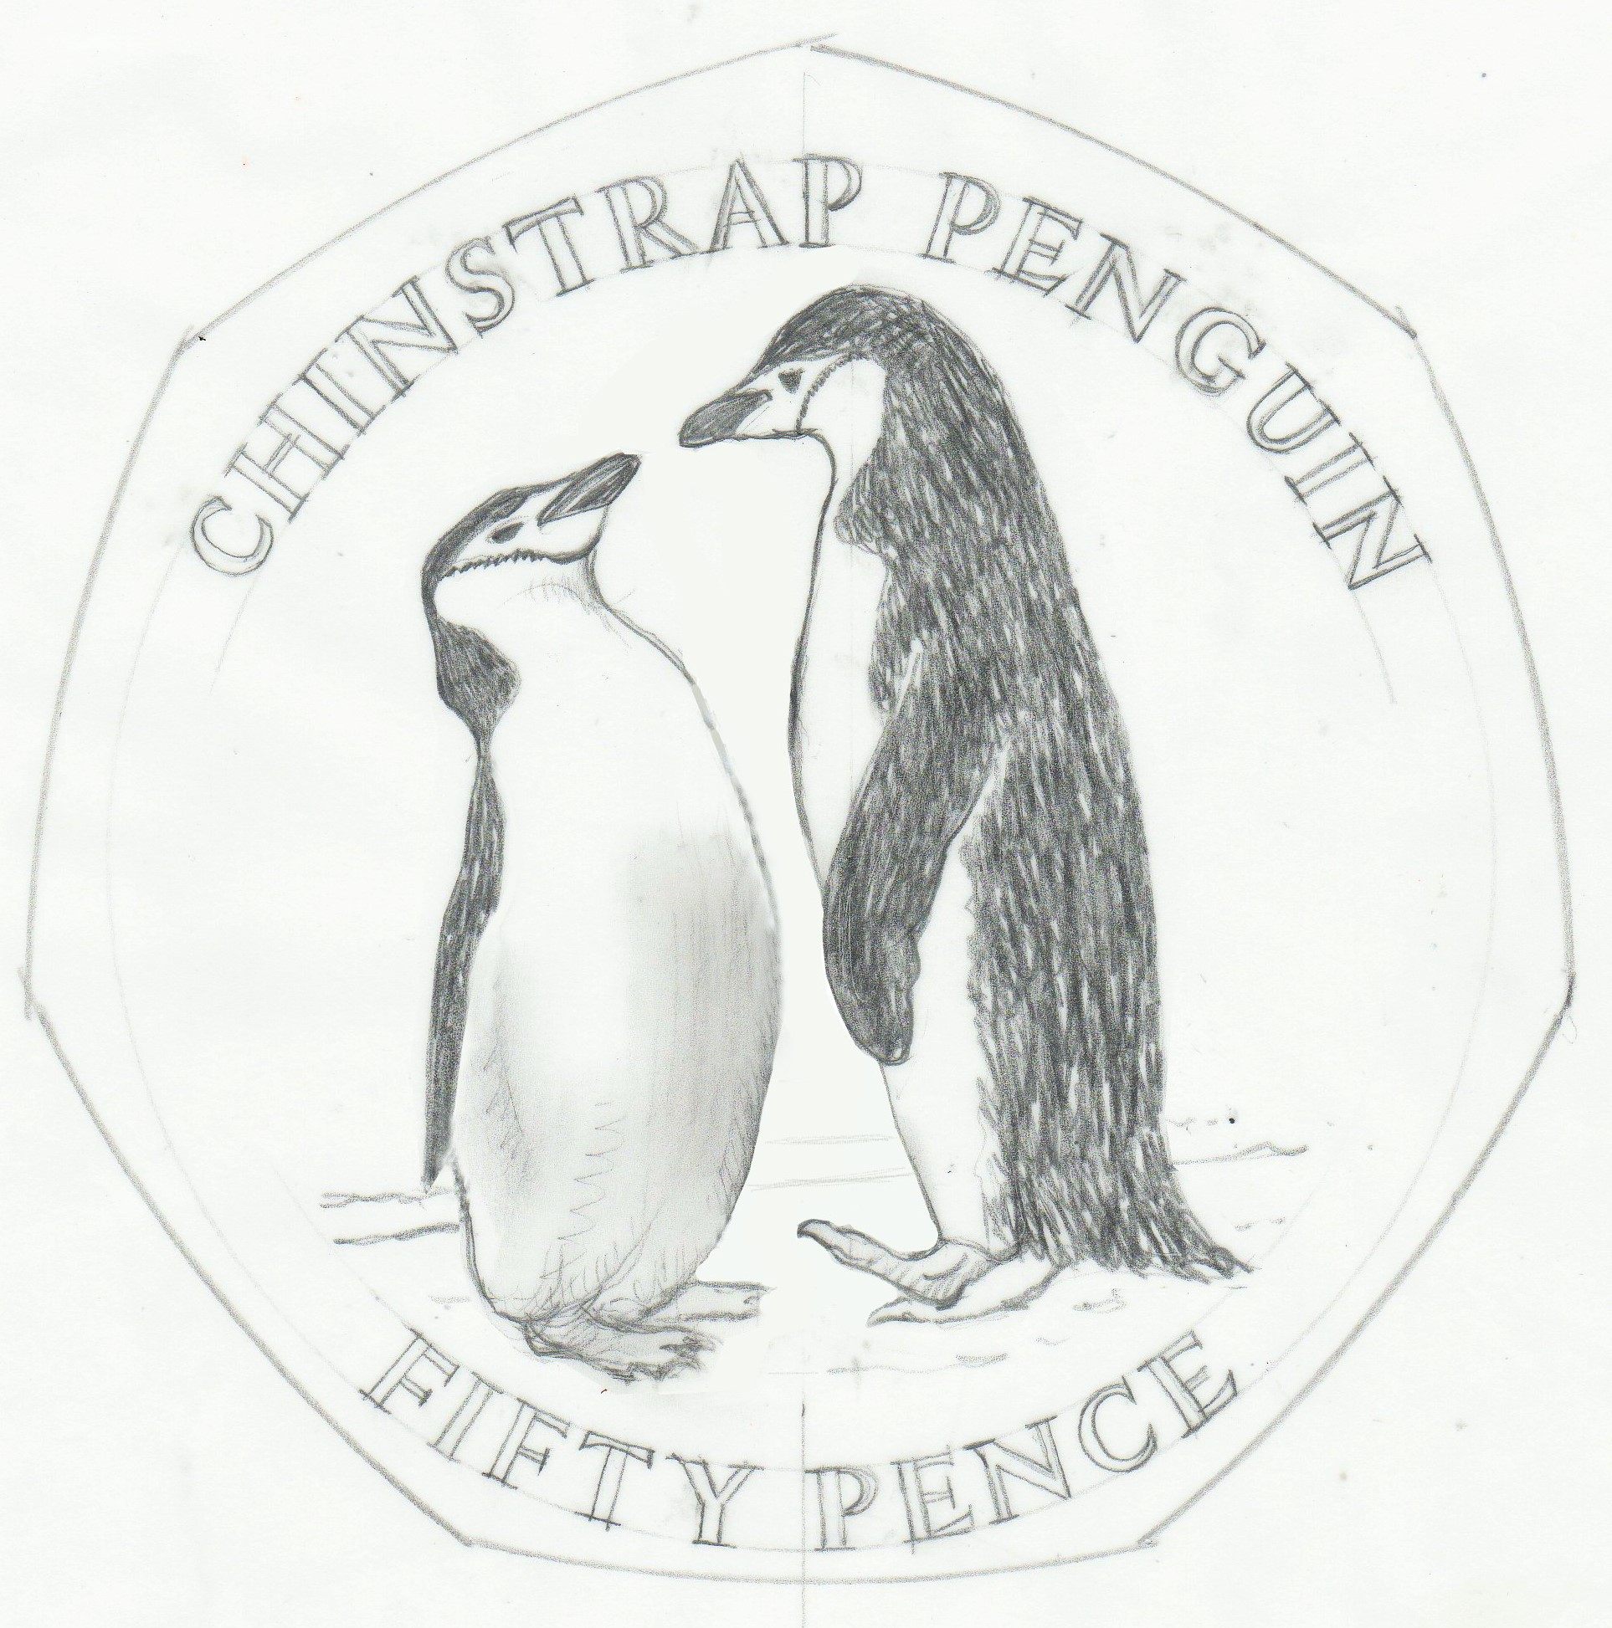

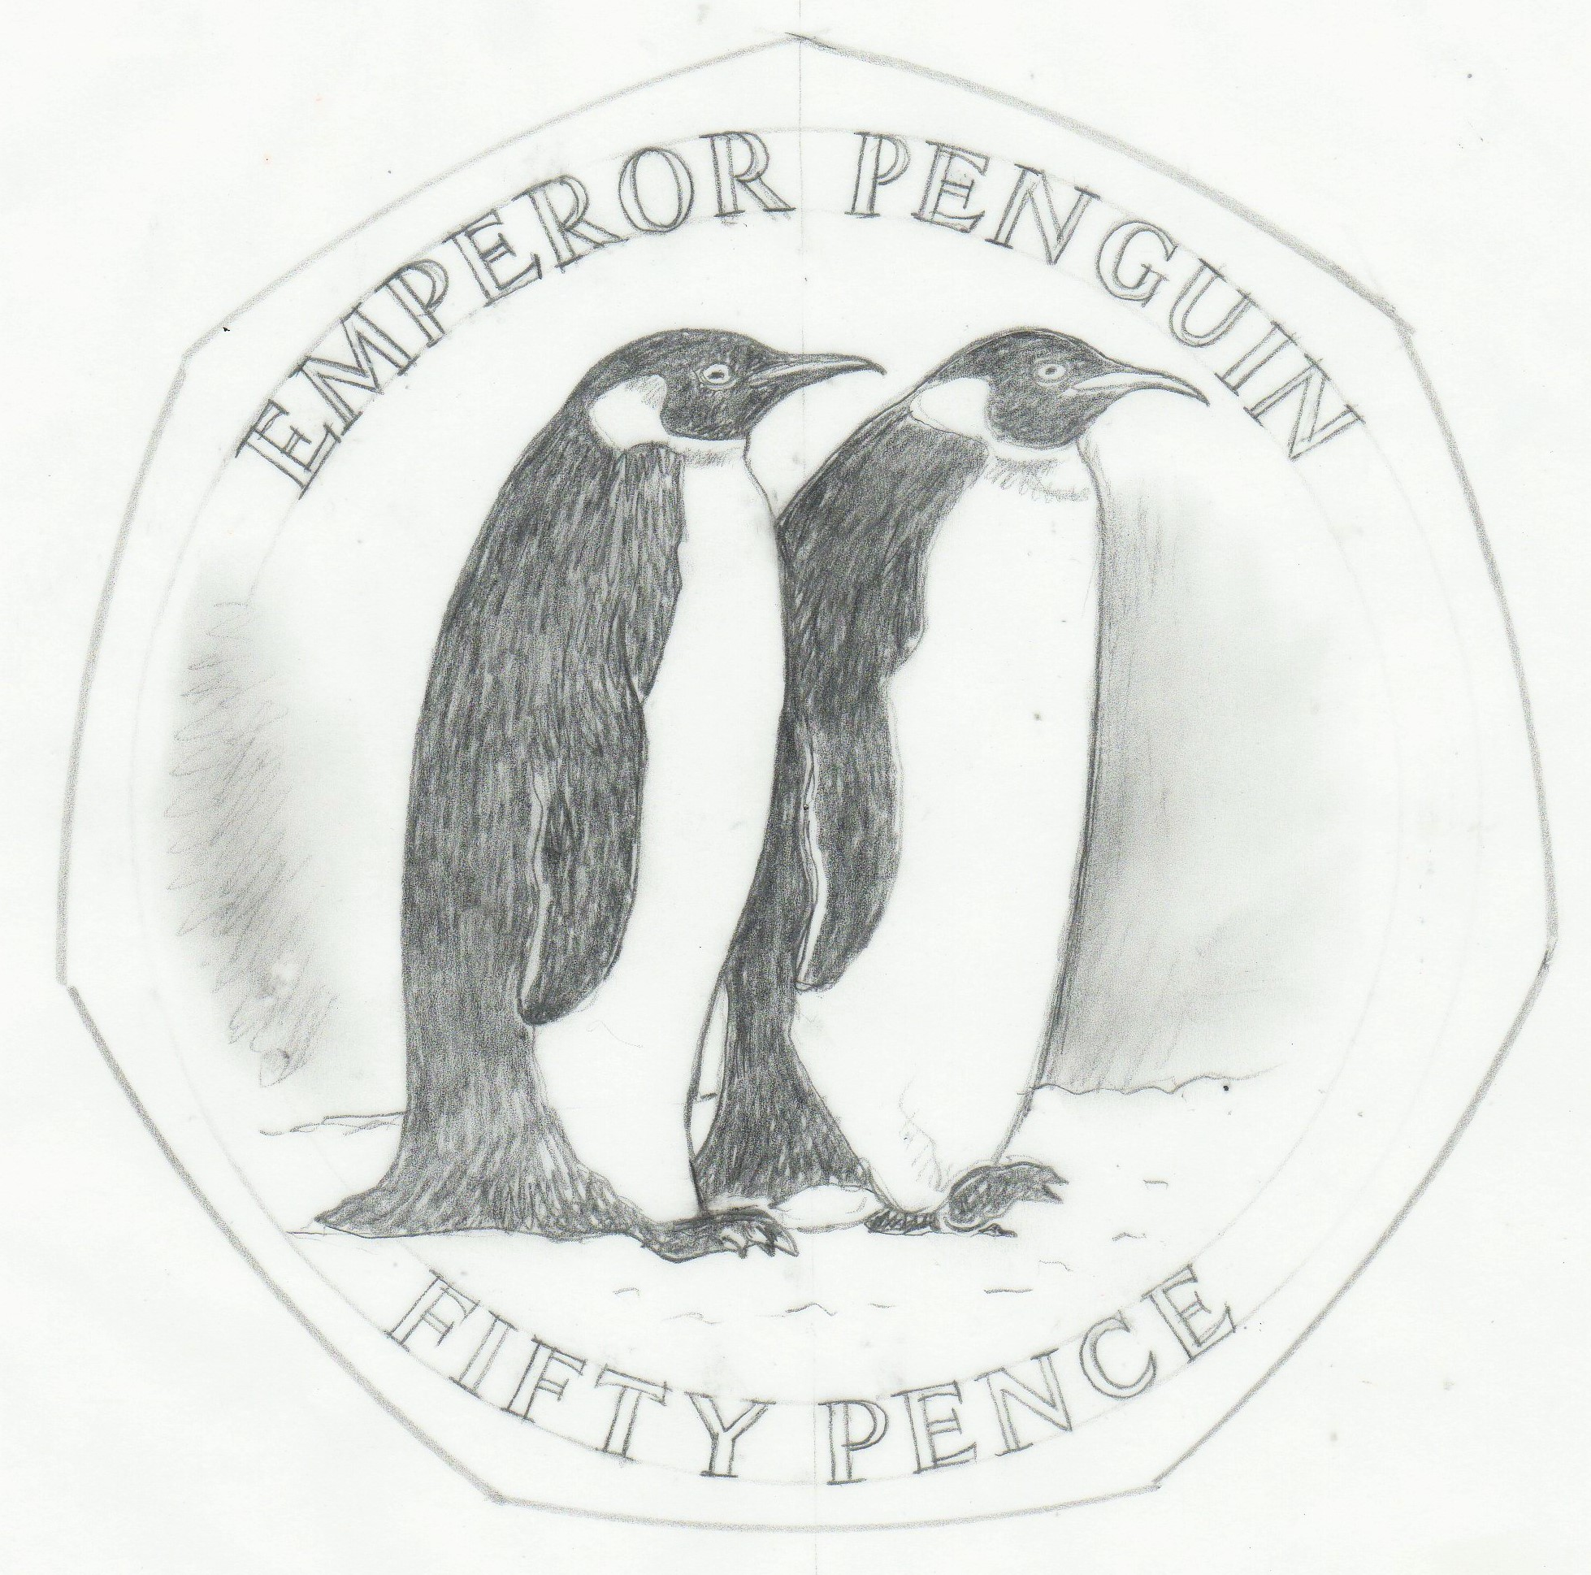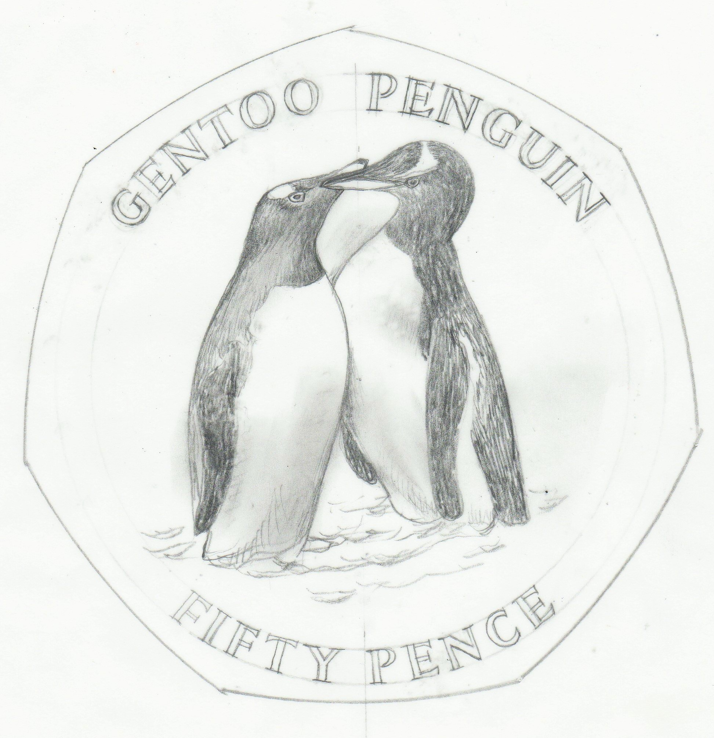

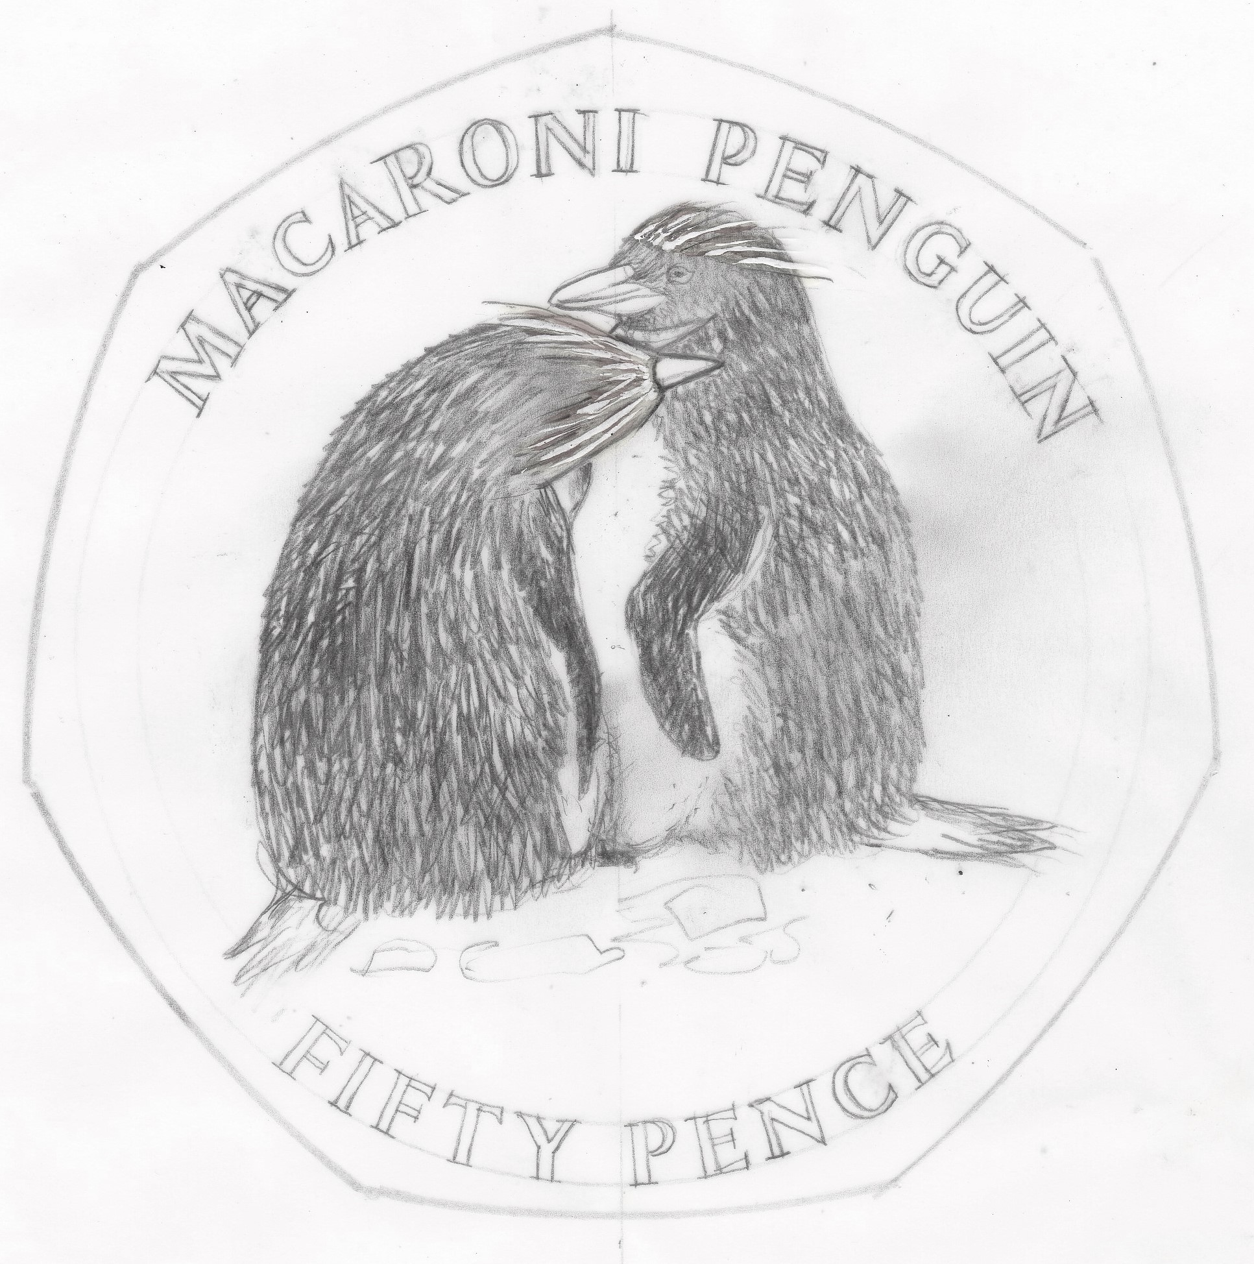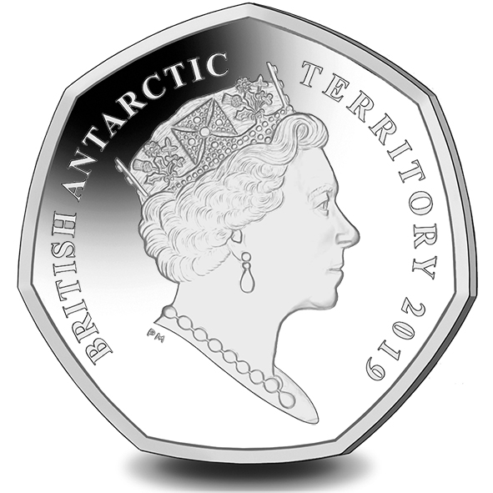

IN WITNESS whereof the Commissioner has hereto set his hand and the Seal of the Territory this 10th day of January 2019.

[SEALED] Signed by: Ben Merrick, Commissioner

