BRITISH ANTARCTIC TERRITORY

THIS LICENCE is granted by the Commissioner pursuant to section 2(1)(b) of the Currency Ordinance 1990.

1. Pobjoy Mint Limited of Millennia House, Kingswood Park, Bonsor Drive, Kingswood, Surrey is hereby authorised by this licence to-

- make during a period of eighteen months from the date of the grant
of this licence and

- issue during a period of two years from the date of the release agreed
to between the Government and Mint

coins in the quantities and of the design and specification set out in the schedule.

2. It is a condition of this licence that every such coin issued must fully comply with the design and specification set out in the schedule.

3. Each such coin made in accordance with the conditions of this licence shall be legal tender in the Territory for its face value from the first date on which that coin was minted.

THE SCHEDULE
(Design, specification, authorised quantity and authorised mint of coins)
Design: 2020 £2 200 Years Discovery of Antarctica
The obverse of every coin shall consist of the uncouped portrait of Her Majesty Queen Elizabeth II by Pobjoy Mint Ltd surrounded by the inscription "BRITISH ANTARCTIC TERRITORY" and the year of the minting of the coin.
The reverse design features the merchant ship Williams overlaid on a map of Antarctica. The wording ‘200 YEARS DISCOVERY OF ANTARCTICA” is shown at the top of the design with the value at the base.
Specification, authorised quantity and authorised mint of coins:

Type NBCN Fine Silver (with Gold Plate)

Denomination £2 £2

Weight 12.00gms 12.00gms
(grams)

Diameter 28.40mm 28.40mm
(millimetres)

Fineness Nickel Brass/Cupro Nickel Fine 999. Silver with Fine
999.9Gold plated surround
Quality Proof-like Proof

Shape Round Round

Edged Milled Milled

Quantity 2020 199

ANNEX TO THE SCHEDULE

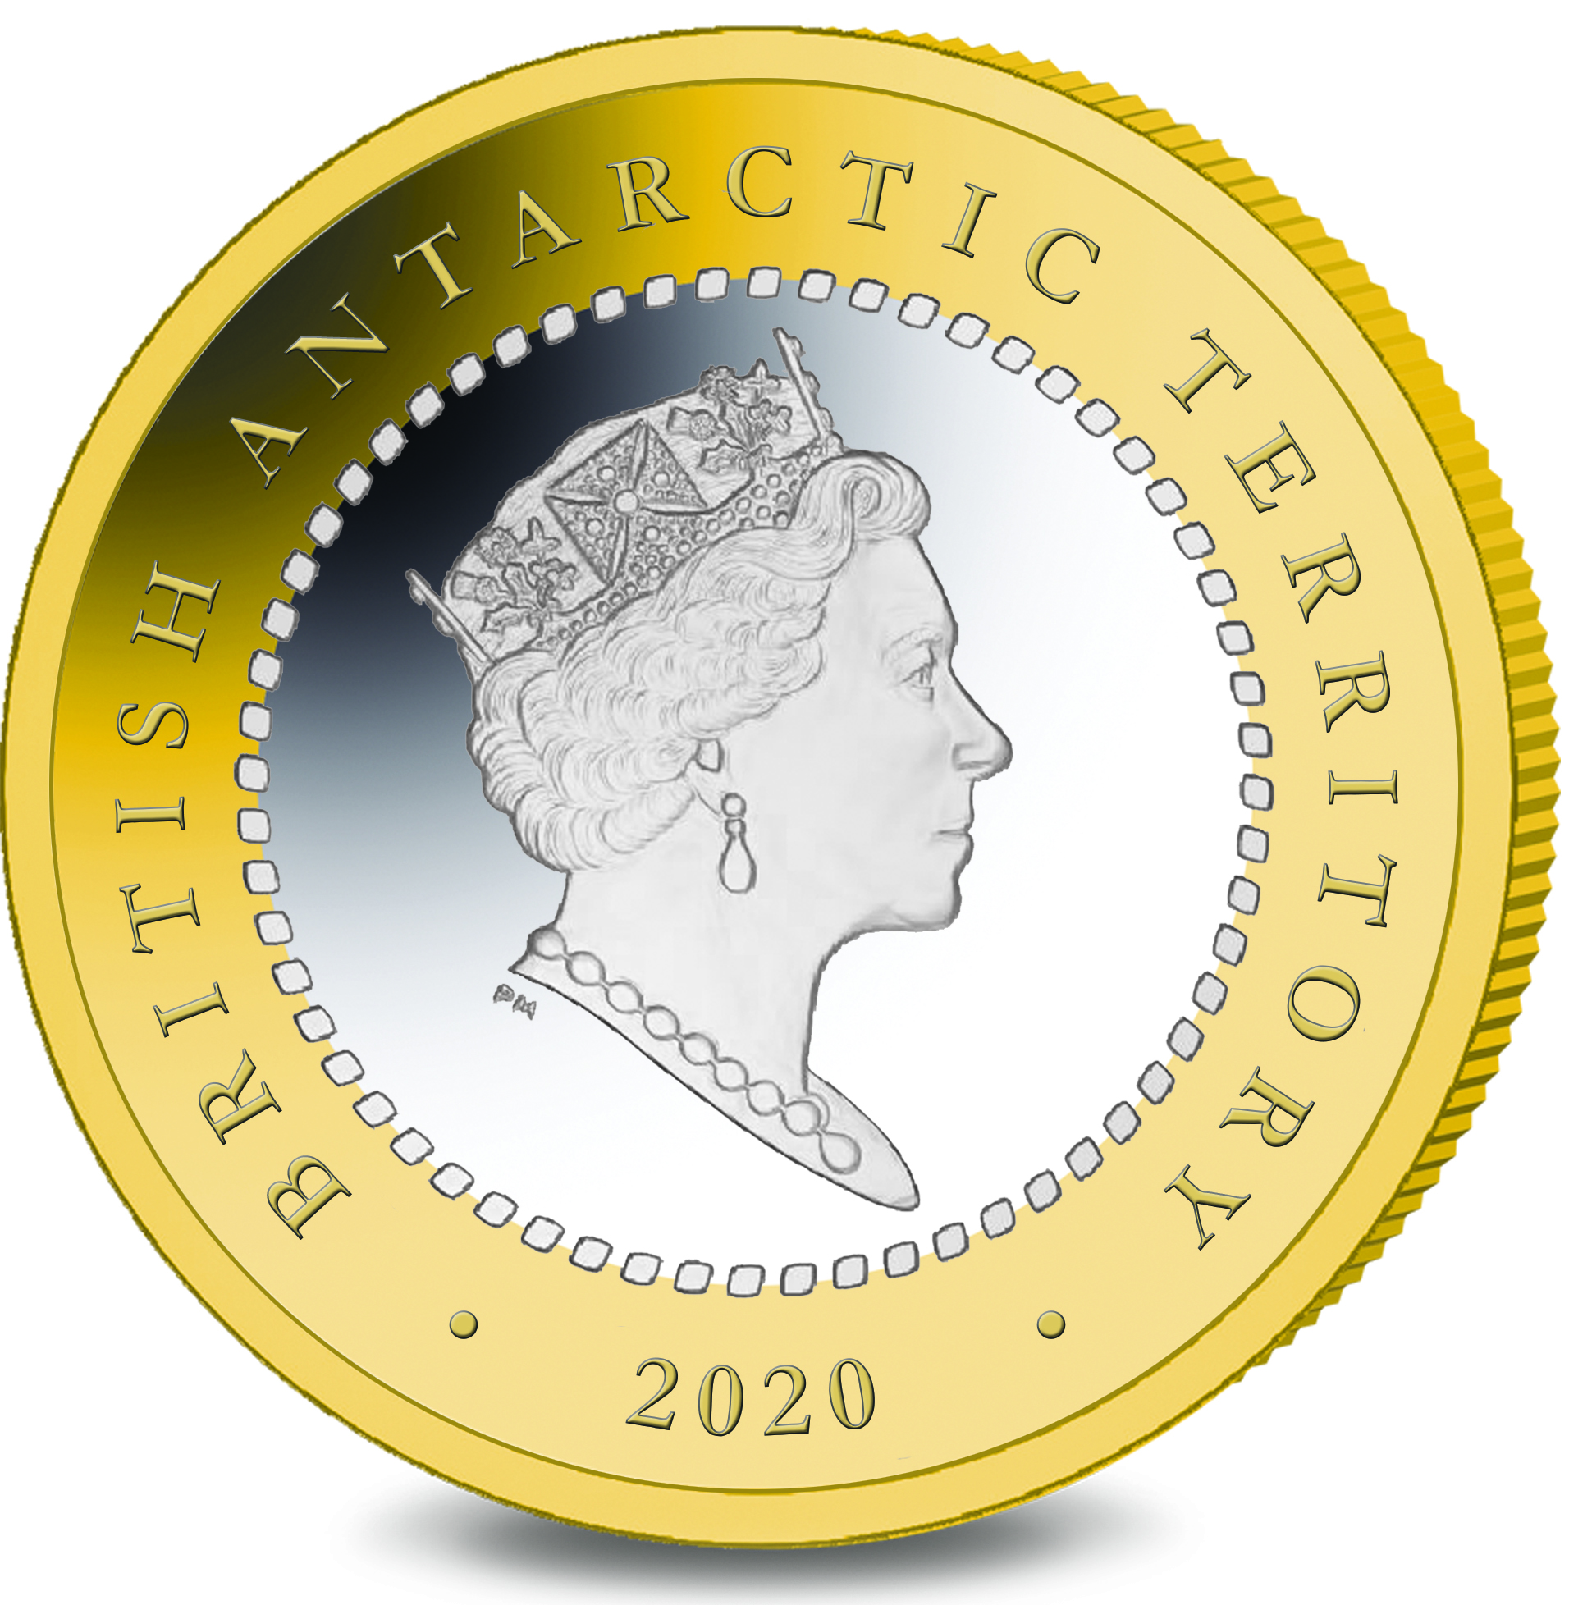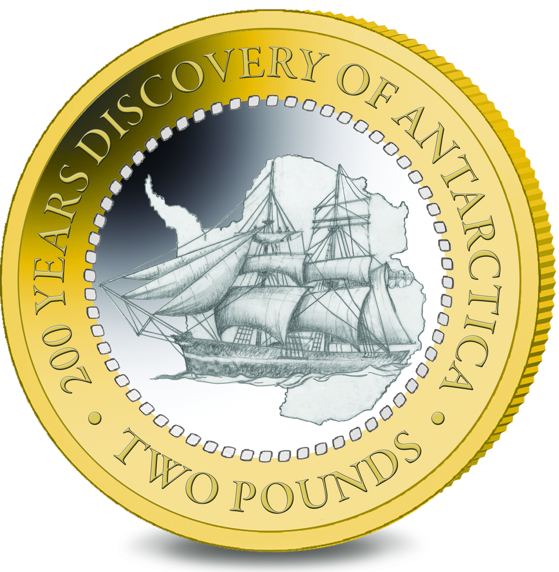

IN WITNESS whereof the Commissioner has hereto set his hand this 1st day of June 2020.

Signed by:
[Ben Merrick
Commissioner]

