BRITISH ANTARCTIC TERRITORY

THIS LICENCE is granted by the Commissioner pursuant to section 2(1)(b) of the Currency Ordinance 1990.

1. Pobjoy Mint Limited of Millennia House, Kingswood Park, Bonsor Drive, Kingswood, Surrey is hereby authorised by this licence to-

- make during a period of eighteen months from the date of the grant
of this licence and

- issue during a period of two years from the date of the release agreed
to between the Government and Mint

coins in the quantities and of the design and specification set out in the schedule.

2. It is a condition of this licence that every such coin issued must fully comply with the design and specification set out in the schedule.

3. Each such coin made in accordance with the conditions of this licence shall be legal tender in the Territory for its face value from the first date on which that coin was minted.

THE SCHEDULE
(Design, specification, authorised quantity and authorised mint of coins)
Design: 2020 HMS Erebus 50p
The obverse of every coin shall consist of the couped portrait of Her Majesty Queen Elizabeth II by Pobjoy Mint Ltd surrounded by the inscription "BRITISH ANTARCTIC TERRITORY" and the year of the minting of the coin.
The reverse design features the ship HMS Erebus. The wording ‘HMS EREBUS’ appears at the base of the design with the value 50 appearing in the field.
Specification, authorised quantity and authorised mint of coins:

Type Silver Proof Cupro Nickel

Demonination 50p 50p

Weight 8.00gms 8.00gms
(grams)

Diameter 27.30mm 27.30mm
(millimetres)

Fineness 925 75%Cu/25%Ni

Quality Proof Diamond Finish

Shape Heptagonal Heptagonal

Edged Plain Plain

Quantity 175 2,750

ANNEX TO THE SCHEDULE

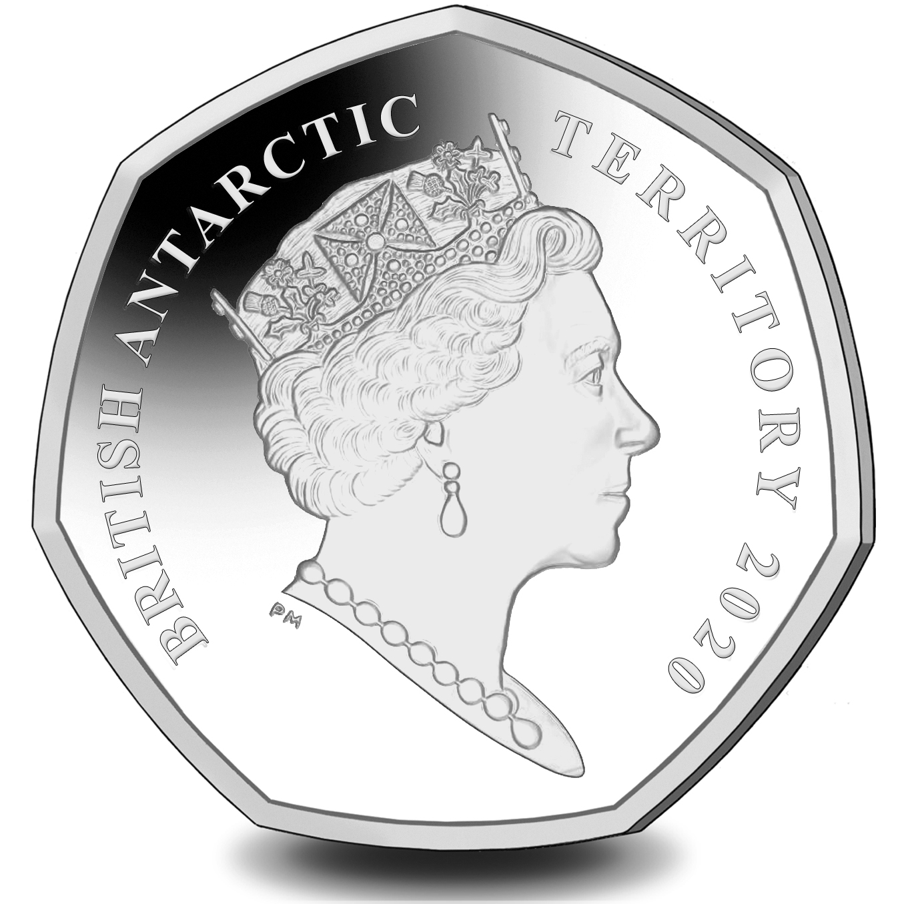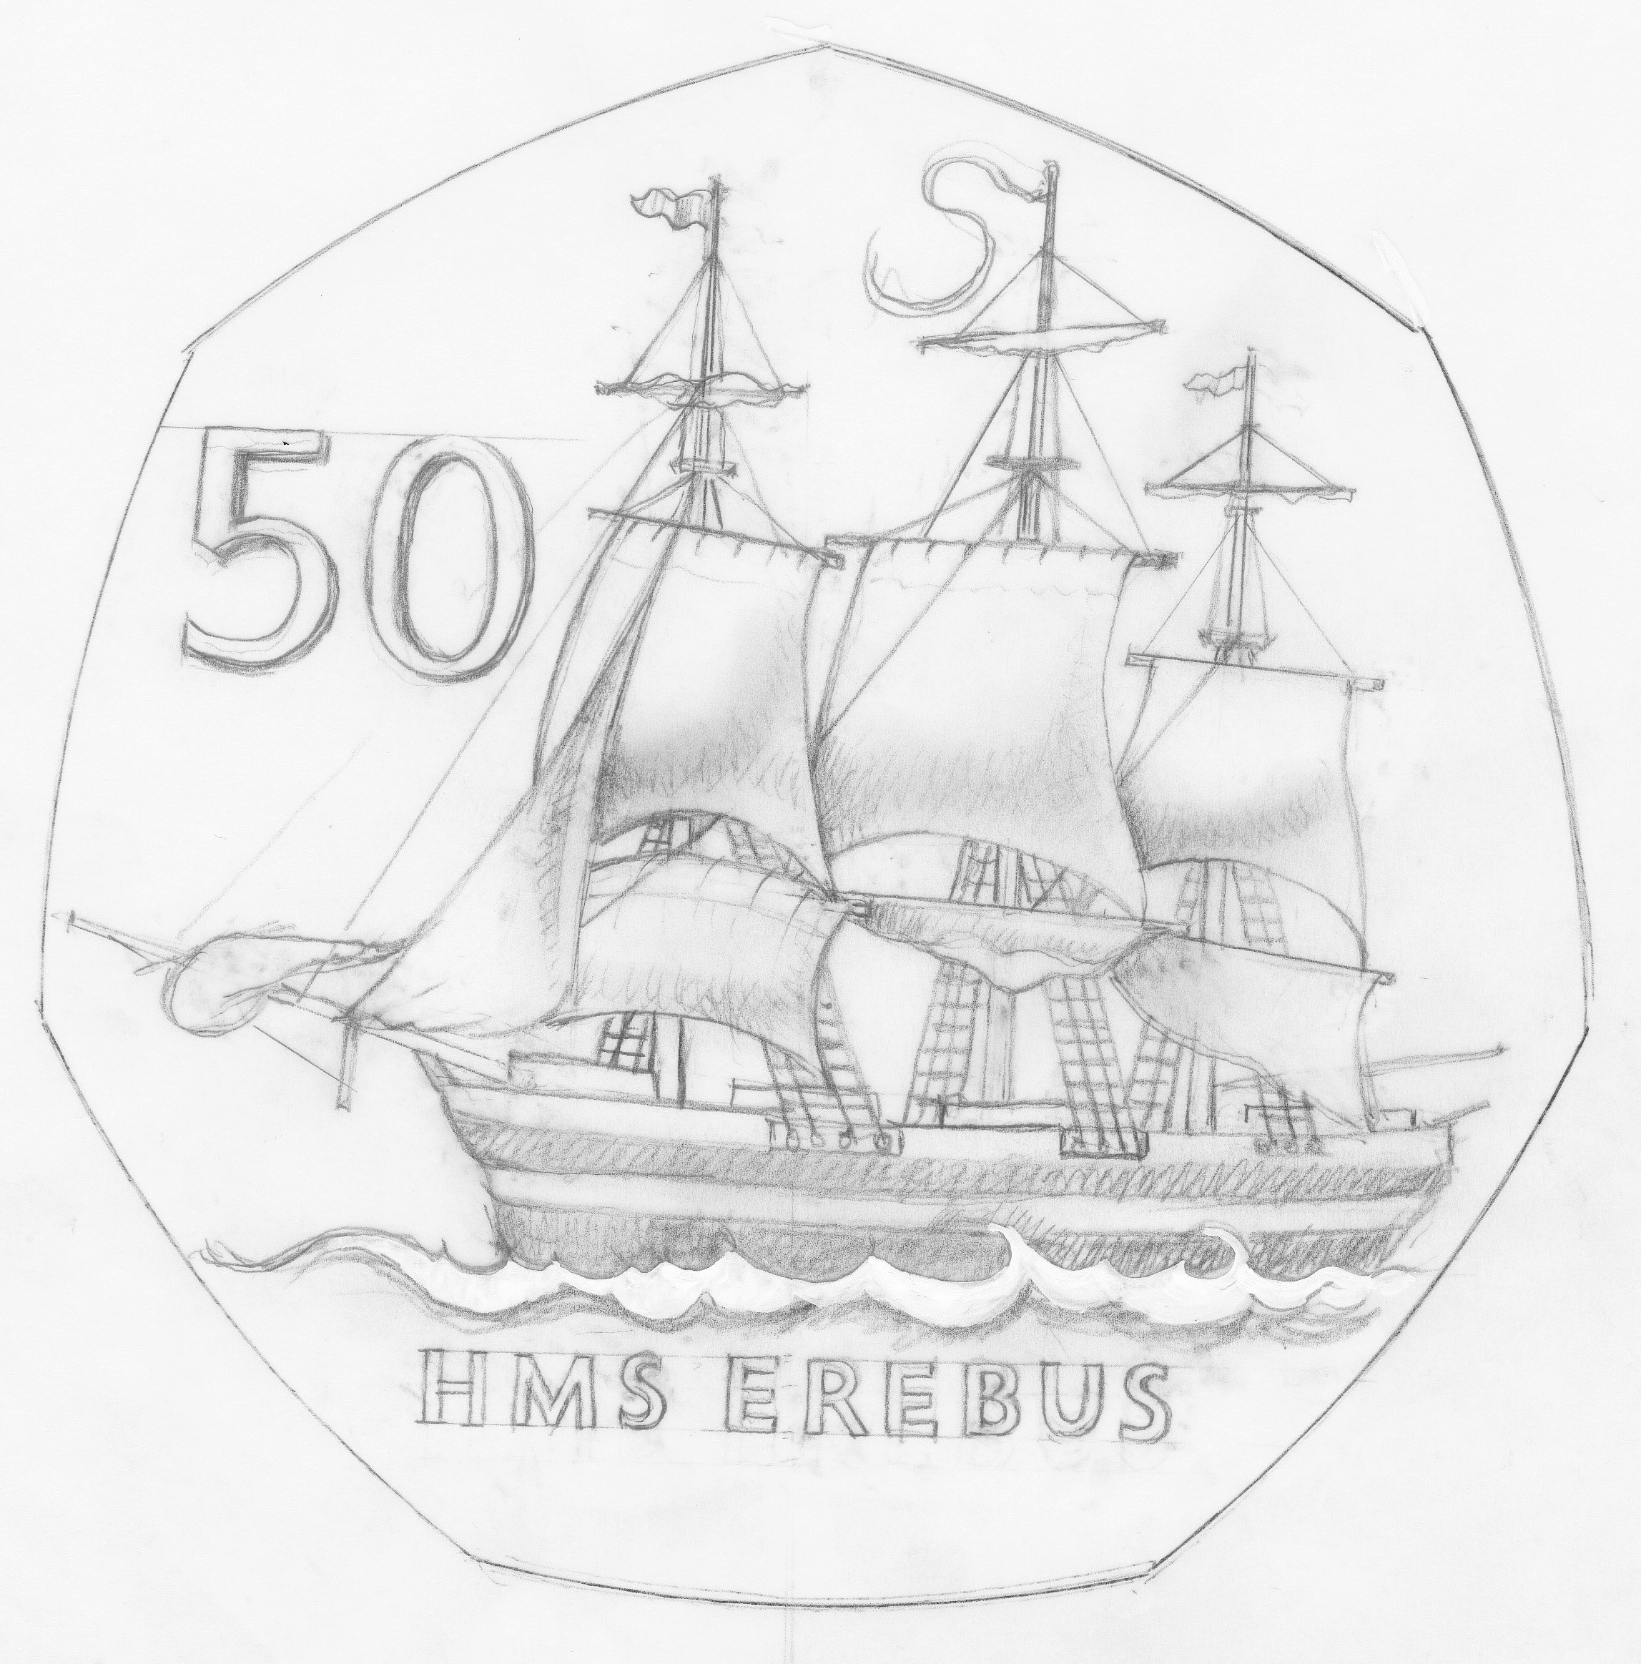

IN WITNESS whereof the Commissioner has hereto set his hand and the Seal of the Territory this 5th day of February 2020.

[SEALED]
Signed by: [Ben Merrick,
Commissioner]

