BRITISH ANTARCTIC TERRITORY

THIS LICENCE is granted by the Commissioner pursuant to section 2(1)(b) of the Currency Ordinance 1990.

1. Pobjoy Mint Limited of Millennia House, Kingswood Park, Bonsor Drive, Kingswood, Surrey is hereby authorised by this licence to-

- make during a period of eighteen months from the date of the grant
of this licence and

- issue during a period of two years from the date of the release agreed
to between the Government and Mint

coins in the quantities and of the design and specification set out in the schedule.

2. It is a condition of this licence that every such coin issued must fully comply with the design and specification set out in the schedule.

3. Each such coin made in accordance with the conditions of this licence shall be legal tender in the Territory for its face value from the first date on which that coin was minted.

THE SCHEDULE

(Design, specification, authorised quantity and authorised mint of coins)

Design: 2021 Polar Zone

The obverse of every coin shall consist of the uncouped portrait of Her Majesty Queen Elizabeth II by Pobjoy Mint Ltd surrounded by the inscription “BRITISH ANTARCTIC TERRITORY” and the year of the minting of the coin.

The reverse design shows an Antarctic Orca Whale swimming in the Antarctic Ocean with an iceberg in the shape of Antarctica behind. An Antarctic Fur Seal is show sitting on an ice pack. The wording ‘POLAR ZONE’ appears at the top of the design with the value incorporated into the design.

Specification, authorised quantity and authorised mint of coins:

Type Silver Proof

Denomination Two Pounds

Weight 31.103gms
(grams)

Diameter 38.60mm
(millimetres)

Fineness 999

Quality Proof

Shape Round

Edged Milled

Quantity 3,000

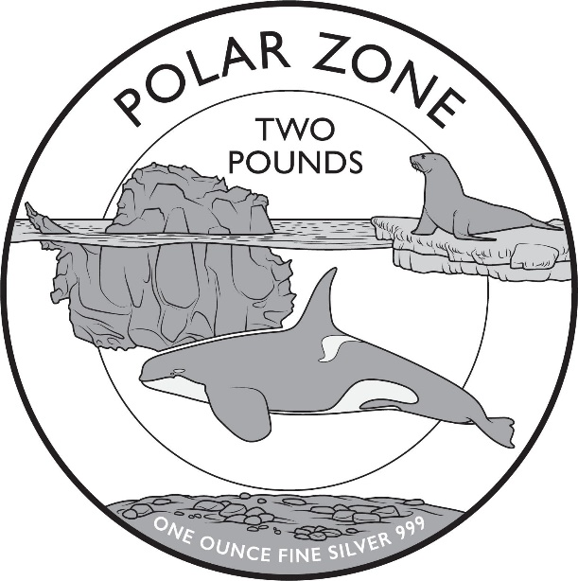
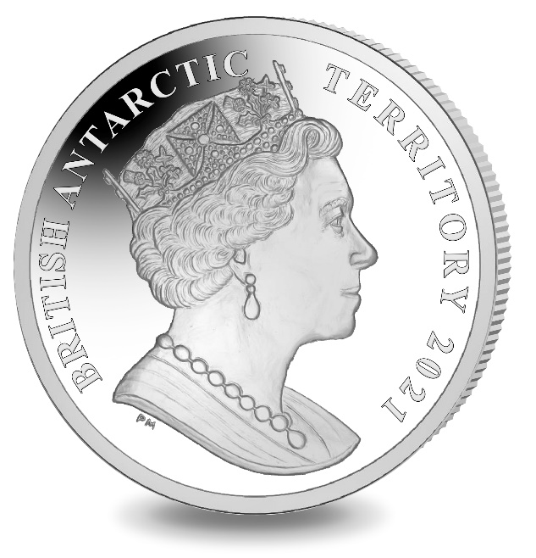

ANNEX TO THE SCHEDULE

IN WITNESS whereof the Commissioner has hereto set his hand this 25th day of February 2021.

[SEALED]

Signed by:
[Ben Merrick
Commissioner]

