BRITISH ANTARCTIC TERRITORY

THIS LICENCE is granted by the Commissioner pursuant to section 2(1)(b) of the Currency Ordinance 2021.

1. Pobjoy Mint Limited of Millennia House, Kingswood Park, Bonsor Drive, Kingswood, Surrey is hereby authorised by this licence to-

- make during a period of eighteen months from the date of the grant
of this licence and

- issue during a period of two years from the date of the release agreed
to between the Government and Mint

coins in the quantities and of the design and specification set out in the schedule.

2. It is a condition of this licence that every such coin issued must fully comply with the design and specification set out in the schedule.

3. Each such coin made in accordance with the conditions of this licence shall be legal tender in the Territory for its face value from the first date on which that coin was minted.

THE SCHEDULE
(Design, specification, authorised quantity and authorised mint of coins)
Design: 2022 £2 60th Anniversary of British Antarctic Territory Being Formed and 70th Anniversary of the Granting of the Coat of Arms
The obverse of every coin shall consist of the couped portrait of Her Majesty Queen Elizabeth II by Pobjoy Mint Ltd surrounded by the inscription “BRITISH ANTARCTIC TERRITORY” and the year of the minting of the coin.
The reverse design features an outline of Antarctica with the British Antarctic Territory highlighted within a marked sector. The Coat of Arms of the British Antarctic Territory is also featured on the design. The wording in the surround reads ‘BRITISH ANTARCTIC TERRITORY 1962-2022’ with the value also shown in the surround.
Specification, authorised quantity and authorised mint of coins:

Type | NBCN | Fine Silver (Gold Plate)
Denomination | £2 | £2
Weight | 12.00gms | 12.00gms (grams)
Fineness | Nickel Brass/Cupro Nickel Fine 999. | Silver with Fine 999.9 Gold plated
Quality | Proof-like | Proof
Shape | Round | Round
Edged | Milled | Milled
Quantity | 1,950 | 195

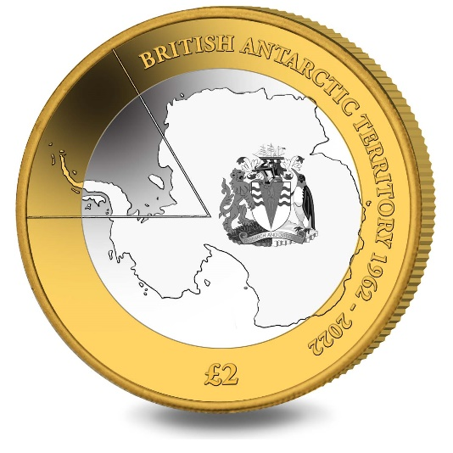
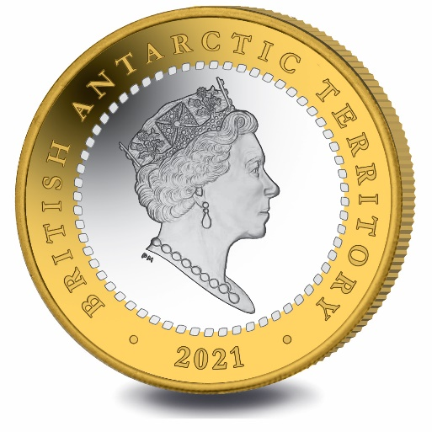
ANNEX TO THE SCHEDULE

IN WITNESS whereof the Commissioner has hereto set his hand this 18th day of January 2022.

.[SEALED] Signed by:
[Paul Candler
Commissioner]

