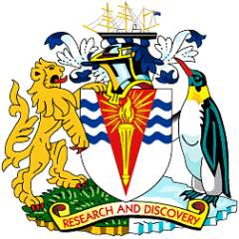

CONSERVATION AND PROTECTION OF BRITISH HERITAGE IN THE BRITISH ANTARCTIC TERRITORY
HEADLINE STRATEGY
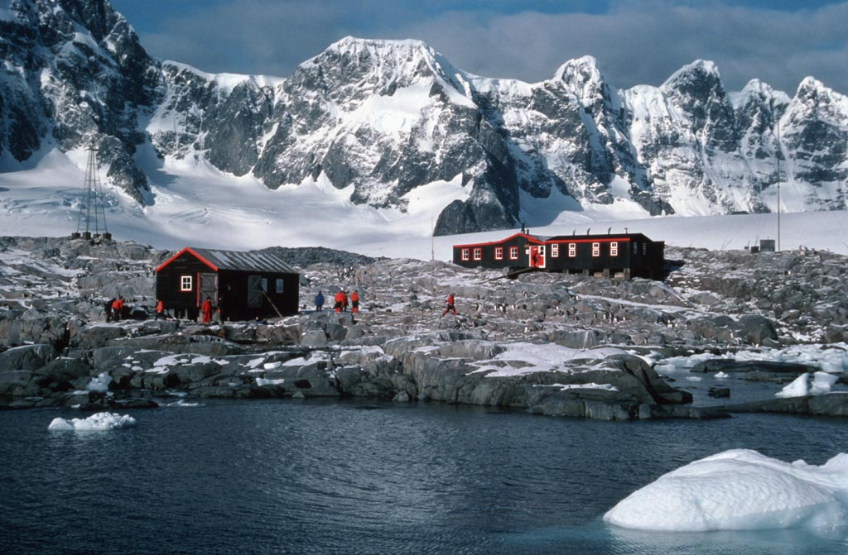

Developed in Partnership with:



HEADLINE STRATEGY FOR THE CONSERVATION AND PROTECTION OF BRITISH HERITAGE IN THE BRITISH ANTARCTIC TERRITORY

SUMMARY
The Government of the British Antarctic Territory (BAT) will work in partnership with the Foreign, Commonwealth & Development Office (FCDO), the United Kingdom Antarctic Heritage Trust (UKAHT), the British Antarctic Survey (BAS), and other stakeholders, as appropriate, to:
- Identify and help protect British sites of heritage value across the British Antarctic Territory;
- Ensure that appropriate management plans are developed for each historic site, including their integral artefacts and structures;
- Communicate the significance of the heritage sites, and the wider context of the history of the British Antarctic Territory; and
- Maintain a record of the status and condition of all sites of British heritage value in the British Antarctic Territory.

BRITISH HERITAGE SITES IN THE BRITISH ANTARCTIC TERRITORY

- It is essential that the legacy of UK endeavour and scientific curiosity, which have formed the backbone of UK presence in the British Antarctic Territory since the heroic age, is maintained for future generations. Paramount to achieving this is a full understanding and awareness of that history. While people may have differing views on what is and what isn’t heritage, it is important that all sites of British activity are recorded and, where appropriate, preserved.

- There are seven former British bases within the BAT, listed as Historic Sites and Monuments (HSM) under Annex V of the Protocol on Environmental Protection to the Antarctic Treaty. The UK is also identified as a “Party undertaking management” for a further six HSM designated sites within the BAT. These are listed in Annex A.

- In addition, the British Antarctic Survey retains responsibility for maintaining and conserving graves, monuments and memorials to those Britons who have died in Antarctica in support of the British Antarctic programme since 1944. The full list of such sites is at Annex B.

- These sites, and others for which there is British heritage interest, will be included in a full register for the BAT. In addition to the HSMs and graves monuments and memorials listed in Annexes A and B, this will include sites that have thus far had no historical preservation or recording, and sites which are currently only marked by signs. Where possible all sites will be surveyed and photographed.

- To support this process, a set of heritage assessment criteria are being written to provide a more standardised approach to the assessment of heritage value (both for new sites / artefacts and the on-going assessment of existing sites). These criteria will include considerations of integrity, authenticity, evidential and historical value, in addition to the pragmatic considerations of the cost and logistical resource required to manage the site/object effectively, and the value of doing so.

- In considering any new proposals for designation as a British heritage site, or as a new Historic Site and Monument under the Antarctic Treaty, the Government of the British Antarctic Territory will consult with interested stakeholders to assess the historic significance of the site, the material state of any structures or artefacts, and any risks to the conservation of the site.

- Similarly, if it is assessed that any site has degenerated, or has been damaged, beyond reasonable maintenance and can no longer be supported as a heritage site, the Government of the British Antarctic Territory will consult with interested stakeholders on whether a site should be delisted and/or removed (ensuring compliance with the clean-up provisions of the Environmental Protocol to the Antarctic Treaty).

- The British Antarctic Survey should fully assess the historical importance of any of its existing buildings (and artefacts) prior to any decision to remove, rebuild or significantly alter them.

KEY MANAGEMENT PRINCIPLES  Overall Principles:  - The Guidelines for the designation and protection of Historic Sites and Monuments, as appended to Resolution 3(2009), agreed at the Antarctic Treaty Consultative Meeting XXXII, and any future amended guidelines, will be the minimum requirement for the long-term conservation of sites. The BAT Government will also take note of any new guidelines or other appropriate material produced as part of the Committee for Environmental Protection’s heritage review. | 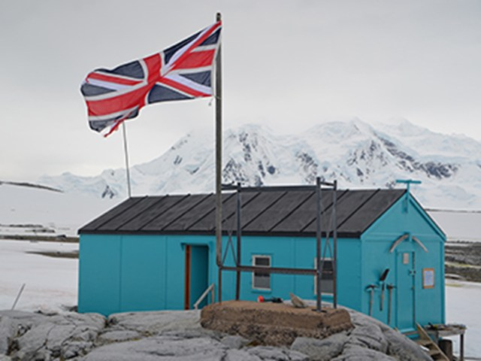Damoy
- For those sites preserved by the UKAHT under their MOU with the BAS, the UKAHT will aim to maintain the sites, as far as practicable, to the highest international standards of heritage management, as set out in the UKAHT strategy. The BAT Government will support UKAHT in these efforts both with monetary and practical support.

- Other sites, as far as practicable, and in line with the heritage assessment criteria, will be monitored and where necessary, conserved in a timely and sympathetic manner, using the best available knowledge, skills and standards, with the aim of preserving the heritage significance of the sites for as long as possible.

- A key objective is to improve public awareness and understanding of the significance of these historic sites, and the broader history of the BAT. This will be addressed in a number of ways, including by creating well-maintained online materials, working with partner organisations on engagement activity, and by providing interpretative material, where appropriate, at the sites themselves.

- The aim is to make a survey of each site at approximate intervals of five years to determine the condition of the structures and the artefacts. This will be carried out within the limits of available finance and the logistics of access.

- All signs within the BAT which were put in place by the UK should be recorded and reviewed for accuracy (including any contact details given), relevance and security. Thereafter each sign should be reviewed at least every 5 years.

Principles of Site Management:

- Priority will be accorded to those sites listed as Historic Sites and Monuments under the Antarctic Treaty for which the UK is a Party undertaking management.

- Conservation action will be prioritised on the basis of the historic significance of the site, the material state of any structures or artefacts, and any risks to the protection of the site:

- Conservation Management Plans (CMP) will be developed for each site based upon detailed surveys of the sites and their integral structures and artefact. These will be developed drawing on expertise from a range of sources to ensure the sites are managed to appropriate international standards;

- A collections management framework will be put in place for the care and management of the collections of artefacts at the HSMs. The policies developed within this will ensure that the conservation, documentation, access and development (acquisitions and disposals) of the collections will be undertaken to the standards set out by Museum Accreditation and PAS:197. As a rule artefacts will only be permanently removed from Antarctica for environmental, safety or security reasons; and

- Should artefacts be removed from Antarctica, they will be appropriately archived, restored and preserved. Where it is deemed appropriate not to return items to their original location, best efforts should be made to make the items accessible to the public.

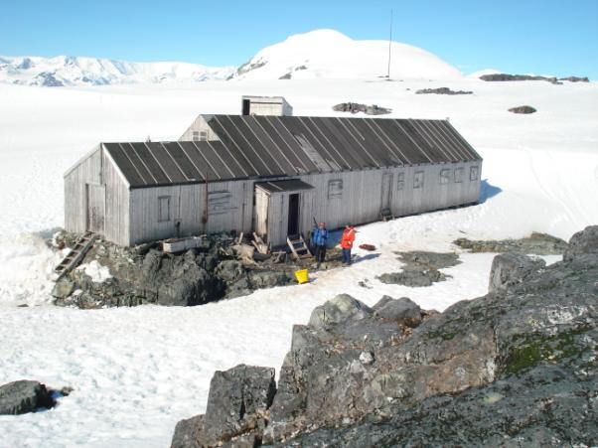
Detaille

WIDER HERITAGE STRATEGY IN THE BAT

- UK operations in the BAT (including by HMG and UKAHT) should be conscious of the heritage of other nations within the Territory. The status and condition of official HSMs should be monitored when the sites are visited and reported back to the FCDO. Other sites which are not HSMs but are in the vicinity of UK bases or activity should be treated with the utmost care. No action should be taken on such sites without the permission of the FCDO or in collaboration/ with the support of the originating Party. Where we can reasonably support the maintenance of such sites we should endeavour to do so.

- The UK has passed the responsibility for several of its former bases to other Parties – notably Faraday Station (now Vernadsky Station) to Ukraine and Hope Bay Station (now Teniente Ruperto Elichiribehety Base) to Uruguay. Full responsibility for these sites now rests with those Parties; however, the UK will continue to take an active interest in the future of these sites.

- The British Antarctic Survey, together with other Parties to this Strategy, should give further consideration to the preservation and maintenance of the tools and equipment used in the BAT which are of particular importance in the history of UK activity in the Territory and could be preserved ex-situ.
STRATEGY OVERSIGHT AND DELIVERY

- The Historic Bases Working Group (which includes all partners to this strategy), will be responsible for overseeing delivery of this strategy and agreeing the management plans for each site. Progress in delivery of the management plans’ objectives will be reviewed annually.

- All parties recognise that the conservation and repair work will be expensive to undertake and that this work will be achieved only through collaboration between the parties and other key stakeholders.

- The Government of the British Antarctic Territory will consider any applications for funding support for major maintenance or conservation projects, or for education/outreach in line with the principles enshrined in this strategy, and within the context of the overall Strategy for the British Antarctic Territory. All on-site maintenance activities will be subject to the usual FCDO permitting procedures set out in the Antarctic Act 1994.

Wordie
ANNEX A

LIST OF HISTORIC SITES AND MONUMENTS DESIGNATED UNDER THE ANTARCTIC TREATY FOR WHICH THE UK IS A PARTY UNDERTAKING MANAGEMENT*

HISTORIC BASES:

Port Lockroy (HSM 61)
‘Base A’ at Port Lockroy, Goudier Island, off Wiencke Island, Antarctic Peninsula. Of historic importance as an Operation Tabarin base from 1944 and for scientific research, including the first measurements of the ionosphere, and the first recording of an atmospheric whistler, over Antarctica. Port Lockroy was a key monitoring site during the International Geophysical Year of 1957/58. (64°49'S, 63°29'W)

Wordie (HSM 62 – UK/Ukraine undertaking management)
‘Base F (Wordie House)’ on Winter Island, Argentine Islands. Of historic importance as an example of an early British scientific base. (65°15'S, 64°16'W)

Horseshoe (HSM 63)
‘Base Y’ on Horseshoe Island, Marguerite Bay, western Graham Land. Noteworthy as a relatively unaltered and completely equipped British scientific base of the late 1950s. ‘Blaiklock’, the refuge hut nearby, is considered an integral part of the base. (67°48'S, 67°18'W)

Stonington (HSM 64)
‘Base E’ on Stonington Island, Marguerite Bay, western Graham Land. Of historical importance in the early period of exploration and later British Antarctic Survey (BAS) history of the 1960s and 1970s. (68°11'S, 67°00'W)

Whalers Bay (HSM 71 – Chile/Norway/UK undertaking management)
Whalers Bay, Deception Island, South Shetland Islands. The site comprises all pre-1970 remains on the shore of Whalers Bay, including those from the early whaling period (1906-12) initiated by Captain Adolfus Andresen of the Sociedad Ballenera de Magallanes, Chile; the remains of the Norwegian Hektor Whaling Station established in 1912 and all artefacts associated with its operation until 1931; the site of a cemetery with 35 burials and a memorial to nine men lost at sea; and the remains from the period of British scientific and mapping activity (1944-1969). The site also acknowledges and commemorates the historic value of other events which occurred there from which nothing remains. (62°59'S, 60°34'W)

Detaille (HSM 83)
Base “W” is situated on a narrow isthmus at the northern end of Detaille Island, Lallemand Fjord, Loubet Coast. The site consists of a hut and a range of associated structures and outbuildings including a small emergency storage building, bitch and pup pens, anemometer tower and two standard tubular steel radio masts (one to the south west of the main hut and the other to the east). Base “W” was established in 1956 as a British science base primarily for survey, geology and meteorology and to contribute to the IGY in 1957. As a relatively unaltered base from the late 1950s, Base “W” provides an important reminder of the science and living conditions that existed when the Antarctic Treaty was signed 50 years ago. (66°52’S, 66°38’W)

Damoy (HSM 84)
The site consists of a well-preserved hut and the scientific equipment and other artefacts inside it. It is located at Damoy Point on Dorian Bay, Wiencke Island, Palmer Archipelago. The hut was erected in 1973 and used for a number of years as a British summer air facility and transit station for scientific personnel. It was last occupied in 1993. (64°49’S, 63°31’W)

OTHER SITES:

HSM 42 (Argentina/UK undertaking management): Area of Scotia Bay, Laurie Island, South Orkney Island, in which are found: stone hut built in 1903 by the Scottish Antarctic Expedition led by William S. Bruce; the Argentine meteorological hut and magnetic observatory, built in 1905 and known as Moneta House; and a graveyard with twelve graves, the earliest of which dates from 1903. (60°46'S, 44°40'W)

HSM 56 (Chile/UK undertaking management): Waterboat Point, Danco Coast, Antarctic Peninsula. The remains and immediate environs of the Waterboat Point hut. It was occupied by the UK two-man expedition of Thomas W. Bagshawe and Maxime C. Lester in 1921-22. Only the base of the boat, foundations of doorposts and an outline of the hut and extension still exist. It is situated close to the Chilean station ‘President Gabriel Gonzáles Videla’. (64°49'S, 62°51'W)

HSM 57 (Chile/UK undertaking management): Commemorative plaque at ‘Yankee Bay’ (Yankee Harbour), MacFarlane Strait, Greenwich Island, South Shetland Islands. Near a Chilean refuge. Erected to the memory of Captain Andrew MacFarlane, who in 1820 explored the Antarctic Peninsula area in the brigantine Dragon. (62°32'S, 59°45'W)

HSM 74: The un-named cove on the south-west coast of Elephant Island, including the foreshore and the intertidal area, in which the wreckage of a large wooden sailing vessel is located. (61°14'S, 55°22'W)

HSM 93: Endurance, Wreck of the vessel owned and used by Sir Ernest Shackleton during his 1914-15 Trans-Antarctic Expedition. Wreck of the vessel Endurance, including all artefacts contained within or formerly contained within the ship, which may be lying on the seabed in or near the wreck within a 150m radius. This includes all fixtures and fittings associated with the ship, including ship’s wheel, bell, etc. The designation also includes all items of personal possessions left on the ship by the ship’s company at the time of its sinking. Location records made by Frank Worsley, Shackleton’s skipper and master navigator give precise coordinates of the location of sinking of the ship but these have not been verified since 1915. We know the wreck is somewhere on the seabed in the Weddell Sea. It is proposed to designate the wreck and all artefacts contained within or formerly contained within the ship, which may be lying on the seabed in or near the wreck.

HSM 94: (Argentina/Norway/Sweden/UK undertaking management): C.A. Larsen Multiexpedition cairn. The site consists of a rock cairn installed in 1892 by Norwegian Capt. Carl Anton Larsen during the first land-exploration of the area around the current location of the Argentina's Marambio Station, where the first Antarctic fossil discoveries were made. The cairn used to have an attached wooden pole (2m high and 5cm diameter) of which nothing remains. (64°14’S, 56°35’W)
ANNEX B

LIST OF GRAVES, MONUMENTS AND MEMORIALS TO THOSE WHO HAVE DIED IN ANTARCTICA IN SUPPORT OF THE BRITISH ANTARCTIC PROGRAMME SINCE 1944.
(Information from BAS Archives Service, July 2009)

Pantomime Point, Signy Island, South Orkney Islands (60° 43' 34" S 45° 34' 48" W)
Grave, with cross and plaque, of Roger Filer, died 13 Feb 1961

Admiralty Bay, King George Island, South Shetland Islands (62° 6' 25" S 58° 25' 17" W)
Grave, with cross and plaque, of Eric Platt, died 10 Nov 1948
Memorial cross, with plaque, for Ronald G Napier, died 24 Mar 1956
Grave, with cross and plaque, of Alan Sharman, died 23 Apr 1959
Memorial cross, with plaque, for Dennis R Bell, died 26 Jul 1959

Whalers Bay, Deception Island, South Shetland Islands (62° 59' 0" S 60° 33' 42" W)
Grave, with cross and plaque, of Arthur H Farrant, died 17 Nov 1953 (In whalers cemetery but destroyed in mudslide caused by the 1969 volcanic eruption.)

Hope Bay, Trinity Peninsula (63° 24' 0" S 57° 0' 0" W)
Grave, with cross and plaque, of Oliver Burd, died 9 Nov 1948
Grave, with cross and plaque, of Michael C Green, died 9 Nov 1948

Petermann Island, Graham Coast (65° 9' 58" S 64° 9' 58" W)
Memorial cross, with plaque, for Ambrose C Morgan, Kevin P Ockleton and John Coll, died 14 Aug 1982

Rasmussen Island, Graham Coast (65° 15' 0" S 64° 6' 0" W)
Memorial cross, with plaque, for Geoffrey H Hargreaves, Michael A Walker and Graham J Whitfield, died Sep 1976

Rothera Point, Adelaide Island (67° 34' 1" S 68° 7' 44" W)
Memorial plaque for Stanley E Black, David Statham and Geoffrey Stride, died 27 May 1958
Memorial cross, with plaque, for John H M Anderson and Robert Atkinson, died 16 May 1981
Memorial cairn, with plaque, for Kirsty M Brown, died 22 July 2003
(There is also a memorial plaque for N J Armstrong (Canada), D N Fredlund (Canada), J C Armstrong (Canada) and E P Odegard (Norway), died 23 Nov 1994)

Flagstaff Hill, Stonington Island, Marguerite Bay (62° 4' 53" S 58° 24' 14" W)
Grave, with cross and plaque, of Thomas J Allan, died June 1966
Grave, with cross and plaque, of John F Noel, died June 1966

Beacon Head, Horseshoe Island, Marguerite Bay (67° 48' 58" S 67° 21' 0" W)
Memorial cross, with plaque, of Stanley E Black, David Statham and Geoffrey Stride, died 27 May 1958

Halley Station, Brunt Ice Shelf (75 34.86 S; 26 40.829 W)
(All 3 plaques mounted on a sledge in the station environs)
Memorial plaque for Neville S Mann, died 15 Aug 1963
Memorial plaque for Jeremy T Bailey, David P Wild and John K Wilson, died 12 Oct 1965 (There is also a plaque at Survey Point, Vardeklettane, Heimfrontfjella.)
Memorial plaque for Miles V Mosley, died 2 Feb 1980

* UK is sole Party undertaking management unless otherwise stated

