BRITISH ANTARCTIC TERRITORY

THIS LICENCE is granted by the Commissioner pursuant to section 2(1)(b) of the Currency Ordinance 2021.
1. Pobjoy Mint Limited of Millennia House, Kingswood Park, Bonsor Drive, Kingswood, Surrey is hereby authorised by this licence to-
- make during a period of eighteen months from the date of the grant of this licence and

- issue during a period of two years from the date of the release agreed to between the Government and Mint coins in the quantities and of the design and specification set out in the schedule.
2. It is a condition of this licence that every such coin issued must fully comply with the design and specification set out in the schedule.
3. Each such coin made in accordance with the conditions of this licence shall be legal tender in the Territory for its face value from the first date on which that coin was minted.

THE SCHEDULE
(Design, specification, authorised quantity and authorised mint of coins)
Design: 2022 £2 Heroic Age of Antarctic Exploration – Southern Cross and Quest Expeditions
The obverse of the coin shall consist of the couped portrait of Her Majesty Queen Elizabeth II by Pobjoy Mint Ltd surrounded by the inscription “BRITISH ANTARCTIC TERRITORY” and the year of the minting of the coin.
The reverse design features Carsten Borchgrevink with the Southern Cross on the left and Ernest Shackleton with the Quest on the right with an iceberg in the background. The Norwegian flag and the Union Flag appear below the explorers. The Coat of Arms of British Antarctic Territory appears below the flags. The wording in the surround reads “HEROIC AGE OF ANTARCTIC EXPLORATION” with the value shown at the base of the design.
Specification, authorised quantity and authorised mint of coins:
Type | NBCN | Fine Silver (with Gold Plate)
Denomination | £2 | £2
Weight (grams) | 12.00gms | 12.00gms
Diameter (millimetres) | 28.40mm | 28.40mm
Fineness | Nickel Brass/Cupro Nickel | Fine 999. Silver with Fine 999.9 Gold plated surround
Quality | Proof-like | Proof
Shape | Round | Round
Edged | Milled | Milled
Quantity | 2,022 | 195

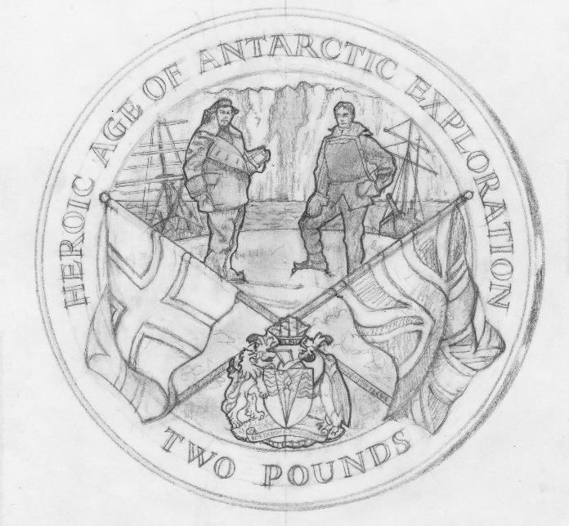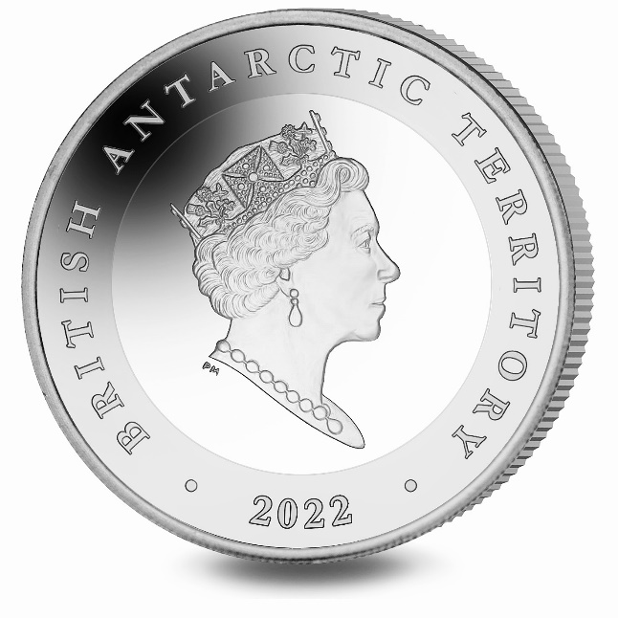

ANNEX TO THE SCHEDULE

IN WITNESS whereof the Commissioner has hereto set his hand this 12th day of April 2022.

[SEALED] Signed by: [Paul Candler, Commissioner]

