BRITISH ANTARCTIC TERRITORY

THIS LICENCE is granted by the Commissioner pursuant to section 2(1)(b) of the Currency Ordinance 2021.

1. Pobjoy Mint Limited of Millennia House, Kingswood Park, Bonsor Drive, Kingswood, Surrey is hereby authorised by this licence to-

- make during a period of eighteen months from the date of the grant
of this licence and

- issue during a period of two years from the date of the release agreed
to between the Government and Mint

coins in the quantities and of the design and specification set out in the schedule.

2. It is a condition of this licence that every such coin issued must fully comply with the design and specification set out in the schedule.

3. Each such coin made in accordance with the conditions of this licence shall be legal tender in the Territory for its face value from the first date on which that coin was minted.

THE SCHEDULE
(Design, specification, authorised quantity and authorised mint of coins)
Design: 2023 75th Birthday of His Majesty King Charles III

The obverse of every coin shall consist of the couped portrait of His Majesty King Charles III by Pobjoy Mint Ltd surrounded by the inscription “BRITISH ANTARCTIC TERRITORY” and the year of the minting of the coin, ‘KING CHARLES III’ and the value.

Coin 1 Reverse Design – the design features Buckingham Palace with the Victoria Memorial in the foreground. An image of the Crown from the Royal Cypher is shown above the Palace. The wording ‘BUCKINGHAM PALACE’ appears below the central design. The inscription ‘KING CHARLES III’ appears above the design with the value shown at the base.

Coin 2 Reverse Design - the design features Trinity College, Cambridge. An image of the badge of Trinity College is shown above the college. The wording ‘TRINITY COLLEGE’ appears below the central design. The inscription ‘KING CHARLES III’ appears above the design with the value shown at the base.

Coin 3 Reverse Design – the design features Caernarfon Castle, Wales. An image of the Prince of Wales feathers is shown above the castle. The wording ‘CAERNARFON CASTLE’ appears below the central design. The inscription ‘KING CHARLES III’ appears above the design with the value shown at the base.

Coin 4 Reverse Design – the design features RAF Cranwell, Lincolnshire with aircraft in the sky above. The wording ‘RAF CRANWELL’ appears below the central design. The inscription ‘KING CHARLES III’ appears above the design with the value shown at the base.

Coin 5 Reverse Design – the design features Windsor Castle. An image of the Order of the Garter Star appears above the castle. The wording ‘WINDSOR CASTLE’ appears below the central design. The inscription ‘KING CHARLES III’ appears above the design with the value shown at the base.

Coin 6 Reverse Design – the design features St James’s Palace. An image of three Royal trumpets appears above the palace. The wording ‘ST JAMES’S PALACE’ appears below the central design. The inscription ‘KING CHARLES III’ appears above the design with the value shown at the base.

Specification, authorised quantity and authorised mint of coins:

Type | Silver Proof | Cupro Nickel
Denomination | 50p | 50p
Weight  Diameter | 8.00gms  27.30mm | 8.00gms  27.30mm
Fineness | 925 | 75%Cu/25%Ni
Quality | Proof | Diamond Finish
Shape | Heptagonal | Heptagonal
Edged | Plain | Plain
Quantity | 99 | 950

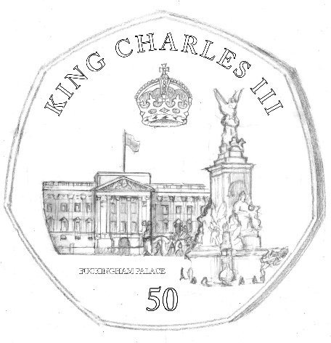
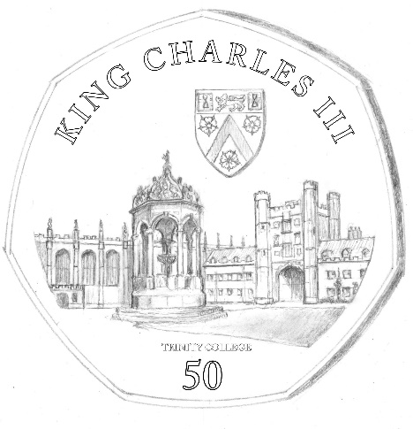
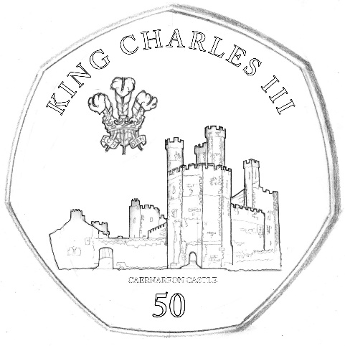
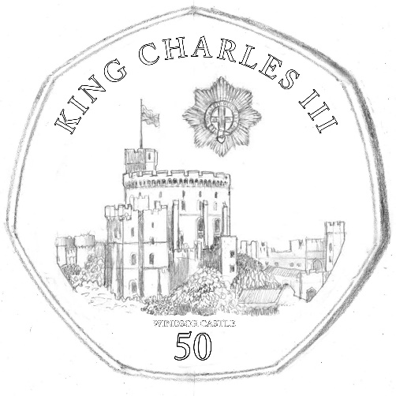
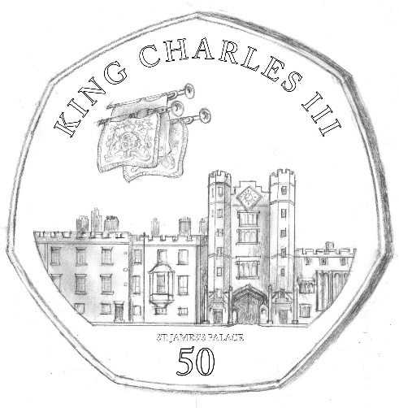
ANNEX TO THE SCHEDULE

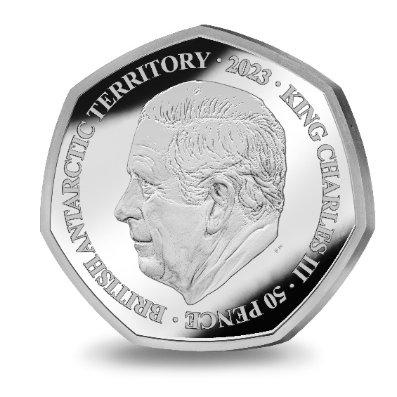
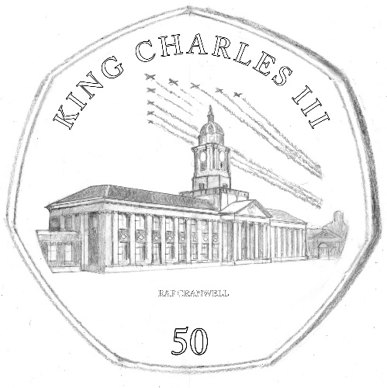

IN WITNESS whereof the Commissioner has hereto set his hand this 7th day of June 2023.

[SEALED] Signed by:
[Paul Candler, Commissioner]

