BRITISH ANTARCTIC TERRITORY

THIS LICENCE is granted by the Commissioner pursuant to section 2(1)(b) of the Currency Ordinance 2021.

1. Pobjoy Mint Limited of Millennia House, Kingswood Park, Bonsor Drive, Kingswood, Surrey is hereby authorised by this licence to-

- make during a period of eighteen months from the date of the grant
of this licence and

- issue during a period of two years from the date of the release agreed
to between the Government and Mint

coins in the quantities and of the design and specification set out in the schedule.

2. It is a condition of this licence that every such coin issued must fully comply with the design and specification set out in the schedule.

3. Each such coin made in accordance with the conditions of this licence shall be legal tender in the Territory for its face value from the first date on which that coin was minted.

THE SCHEDULE
(Design, specification, authorised quantity and authorised mint of coins)
Design: 2023 Lunar South Pole of the Moon 50p

The obverse of every coin shall consist of the couped portrait of His Majesty King Charles II by Pobjoy Mint Ltd surrounded by the inscription “BRITISH ANTARCTIC TERRITORY”, “KING CHARLES III” the value and the year of the minting of the coin.

The reverse design shows the Moon’s surface focussing specifically on the Lunar South Pole and features the Shackleton and Amundsen craters. A privy mark of the NASA logo is also included along with the value at the base of the coin.

Specification, authorised quantity and authorised mint of coins:

Type | Cupro Nickel | Silver | Gold | Gold
Denomination | 50p | 50p | 50p | £4
Weight | 8.00gms (grams) | 8.00gms (grams) | 8.00gms (grams) | 0.5 (grams)
Diameter | 27.30mm | 27.30mm | 27.30mm | 11.00mm
Fineness | 75%Cu/25%Ni | 925. | 22ct | 999.9
Quality | Diamond Finish | Proof | Proof | Proof
Shape | Heptagonal | Heptagonal | Heptagonal | Round
Edged | Plain | Plain | Plain | Milled
Quantity | 1,950 | 175 | 99 | 199

ANNEX TO THE SCHEDULE

IN WITNESS whereof the Commissioner has hereto set his hand this 9th day of May 2023.
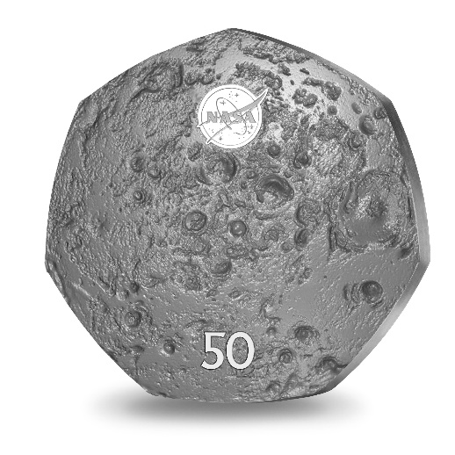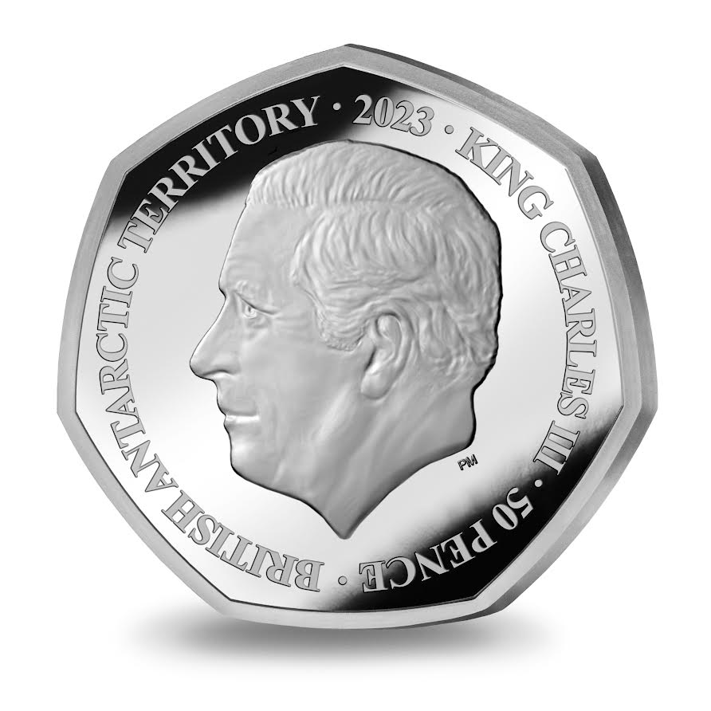

[SEALED] Signed by:
[Paul Candler,Commissioner]

