BRITISH ANTARCTIC TERRITORY

THIS LICENCE is granted by the Commissioner pursuant to section 2(1)(b) of the Currency Ordinance 2021.

1. Pobjoy Mint Limited of Millennia House, Kingswood Park, Bonsor Drive, Kingswood, Surrey is hereby authorised by this licence to-

- make during a period of eighteen months from the date of the grant
of this licence and

- issue during a period of two years from the date of the release agreed
to between the Government and Mint

coins in the quantities and of the design and specification set out in the schedule.

2. It is a condition of this licence that every such coin issued must fully comply with the design and specification set out in the schedule.

3. Each such coin made in accordance with the conditions of this licence shall be legal tender in the Territory for its face value from the first date on which that coin was minted.

THE SCHEDULE
(Design, specification, authorised quantity and authorised mint of coins)
Design: 2023 Coronation of His Majesty King Charles III – State Coach £2

The obverse of every coin shall consist of the couped portrait of His Majesty King Charles III by Pobjoy Mint Ltd surrounded by the inscription “BRITISH ANTARCTIC TERRITORY” and the year of the minting of the coin, ‘KING CHARLES III’ and the value.

The reverse of the coin features an image of the Gold State Coach. The official emblem of His Majesty’s Coronation is incorporated into the design along with the date ‘6th May 2023’. The wording ‘CORONATION OF KING CHARLES III’ appears at the top of the design with the wording ‘LONG LIVE THE KING’ appearing at the base.

Specification, authorised quantity and authorised mint of coins:

Type | NBCN | Fine Silver (with Gold Plate)
Denomination | £2 | £2
Weight  Diameter | 12.00gms  28.40mm | 12.00gms  28.40mm
Fineness | Nickel Brass/ Cupro Nickel | Fine 999. Silver with Fine 999.9 Gold plated
Surround Quality | Proof-like | Proof
Shape | Round | Round
Edged | Milled | Milled
Quantity | 1,950 | 175

ANNEX TO THE SCHEDULE
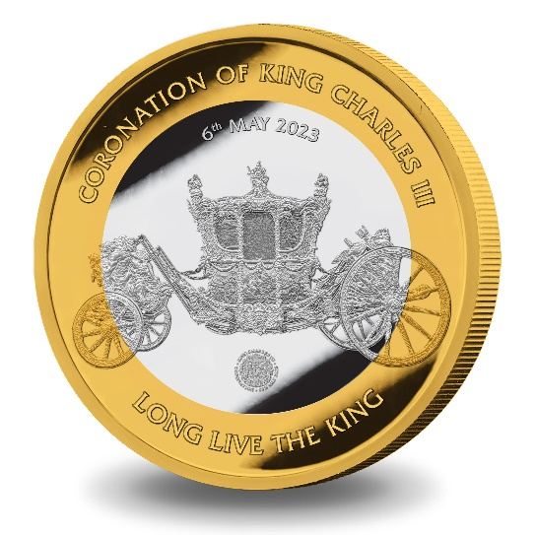
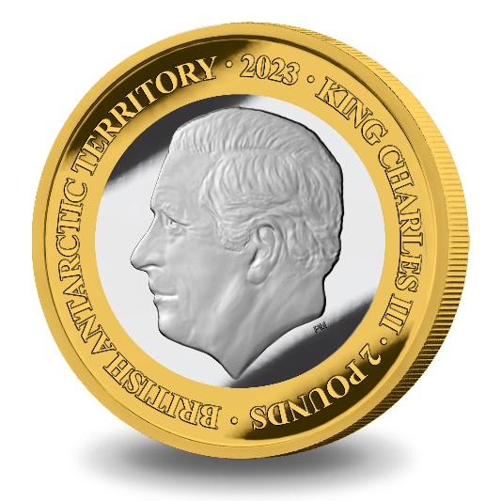

IN WITNESS whereof the Commissioner has hereto set his hand this 2nd day of May 2023.

[SEALED] Signed by:
[Paul Candler, Commissioner]

