BRITISH ANTARCTIC TERRITORY

THIS LICENCE is granted by the Commissioner pursuant to section 2(1)(b) of the Currency Ordinance 2021.

1. Pobjoy Mint Limited of Millennia House, Kingswood Park, Bonsor Drive, Kingswood, Surrey is hereby authorised by this licence to-

- make during a period of eighteen months from the date of the grant
of this licence and

- issue during a period of two years from the date of the release agreed
to between the Government and Mint

coins in the quantities and of the design and specification set out in the schedule.

2. It is a condition of this licence that every such coin issued must fully comply with the design and specification set out in the schedule.

3. Each such coin made in accordance with the conditions of this licence shall be legal tender in the Territory for its face value from the first date on which that coin was minted.

THE SCHEDULE
(Design, specification, authorised quantity and authorised mint of coins)
Design: 2023 Emperor Penguins

The obverse of every coin shall consist of the couped portrait of His Majesty King Charles III by Pobjoy Mint Ltd surrounded by the inscription “BRITISH ANTARCTIC TERRITORY” and the year of the minting of the coin.

The reverse of the coin features a pair of Emperor Penguins standing on the Antarctic ice. The value is shown at the base.

Specification, authorised quantity and authorised mint of coins:

Type | Denomination | Weight | Diameter | Fineness | Quality | Shape | Edge | Quantity
Silver 1oz | £1 | 31.103gms | 38.60mm | Fine 999. silver | Bullion reverse frost | Round | Milled | 10,000
Silver 2oz | £2 | 31.103gms | 38.60mm | Fine 999. silver | Proof | Round | Milled | 1,500
Silver 1oz Ultra High Relief | £2 | 62.21gms | 38.60mm | Fine 999. silver | Proof | Round | Milled | 200
Silver 2oz | £4 | 62.21gms | 50.00mm | Fine 999. silver | Proof | Round | Milled | 500
Silver 2oz | £2 | 62.21gms | 50.00mm | Fine 999. silver | Proof | Round | Milled | 2,500
Silver 5oz | £10 | 155.51gms | 65.00mm | Fine 999. silver | Proof | Round | Milled | 300
Silver 5oz | £5 | 155.51gms | 65.00mm | Fine 999. silver | Bullion | Round | Milled | 1,000
Silver 10oz | £10 | 311.03gms | 75.00mm | Fine 999. silver | Proof | Round | Milled | 100
Gold 1oz | £100 | 31.103gms | 32.00mm | Fine 999. silver | Bullion | Round | Milled | 100
Gold 1/25oz | £4 | 1.24gms | 13.92mm | Fine 999.9 Gold | Proof | Round | Milled | 500
Gold 1/2gm | £2 | 0.5gms | 11.00mm | Fine 999.9 Gold | Proof | Round | Milled | 199
Cupro Nickel | 50p | 8.00gms | 27.30mm | 75%Cu/25%Ni | Diamond Finish | Heptagonal | Plain | 1,950
Silver | 50p | 8.00gms | 27.30mm | 925 | Proof | Heptagonal | Plain | 175

ANNEX TO THE SCHEDULE

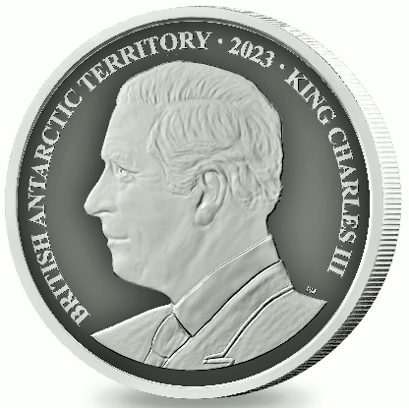
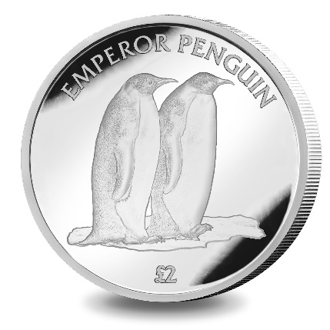

IN WITNESS whereof the Commissioner has hereto set his hand this 11th day of April 2023.

[SEALED] Signed by:
[Paul Candler, Commissioner]

