BRITISH ANTARCTIC TERRITORY

THIS LICENCE is granted by the Commissioner pursuant to section 2(1)(b) of the Currency Ordinance 2021.

1. Pobjoy Mint Limited of Millennia House, Kingswood Park, Bonsor Drive, Kingswood, Surrey is hereby authorised by this licence to-

- make during a period of eighteen months from the date of the grant
of this licence and

- issue during a period of two years from the date of the release agreed
to between the Government and Mint

coins in the quantities and of the design and specification set out in the schedule.

2. It is a condition of this licence that every such coin issued must fully comply with the design and specification set out in the schedule.

3. Each such coin made in accordance with the conditions of this licence shall be legal tender in the Territory for its face value from the first date on which that coin was minted.

THE SCHEDULE
(Design, specification, authorised quantity and authorised mint of coins)
Design: 2023 Royal Cypher of His Majesty King Charles III

The obverse of every coin shall consist of the couped portrait of His Majesty King Charles III by Pobjoy Mint Ltd surrounded by the inscription “BRITISH ANTARCTIC TERRITORY” and the year of the minting of the coin.

The reverse design features the Royal Cypher of His Majesty surrounded by a rose, representing England, a daffodil, representing Wales, a thistle, representing Scotland, and shamrocks representing Northern Ireland. The value is show at the base.

Specification, authorised quantity and authorised mint of coins:

Type | Silver Proof | Cupro Nickel
Denomination | 50p | 50p
Weight  Diameter | 8.00gms  27.30mm | 8.00gms (grams)  27.30mm
Quality | Proof | Diamond Finish
Shape | Heptagonal | Heptagonal
Edged | Plain | Plain
Quantity | 175 | 1,950

ANNEX TO THE SCHEDULE
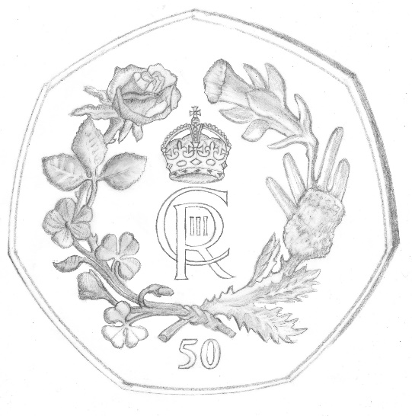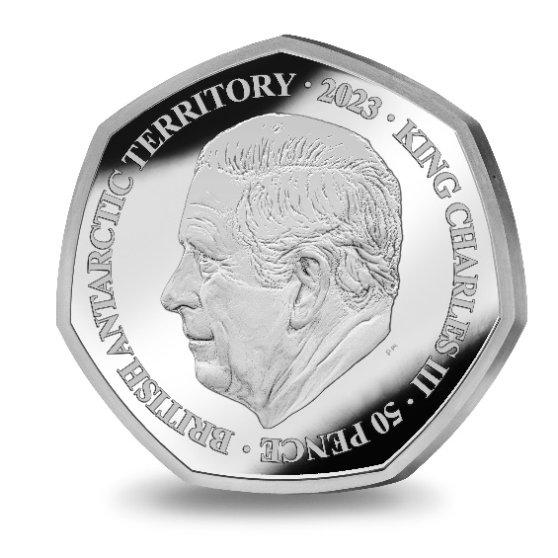

IN WITNESS whereof the Commissioner has hereto set his hand this 27th day of February 2023.

[SEALED] Signed by:
[Paul Candler, Commissioner]

